**TOPIC 1: PLANT RESPONSES**

**What is irritability/sensitivity?**

|  |
| --- |
| It is the ability to detect changes and respond to them appropriately in plants. |

**Major groups of plant responses to stimuli.**

|  |
| --- |
| * **nastic response-** It is the movement exhibited by parts of plant in response in response to non-directional external stimulus. * **Tropic response-** It refers to growth movements by plants in response to light, gravity, chemical, contact and water stimuli. |

**TROPISM**

|  |
| --- |
| Tropism is defined in the following ways:   * It is a growth response towards or away from stimulus coming from one direction. * It is a growth toward or away from a stimulus. * It is a directional plant response which causes part of a plant to growth either towards or away from the stimulus.   Tropism can be positive or negative. Tropism is said to be **positive** if the response is towards the stimulus and it is said to be **negative** if the response is away from the stimulus.  Some examples of tropism include     1. **Gravitotropism** - growth response towards gravity. 2. **Phototropism** - growth response towards the force of light. It is also defined as a plant growth movement or bending of a plant part in response to unilateral stimulation by light. 3. **Thigmotropism-** growth response towards contact. 4. **Hydrotropism-** growth response towards the force of moisture |

**How does tropism occur?**

|  |
| --- |
| Tropism is growth toward or away from a stimulus. It is influenced by stimuli which include light, water, gravity and touch. |

**AUXINS**

|  |
| --- |
| Auxins are the plant growth hormones that cause plants to elongate and grow cells faster on the side of the plant farthest from the light.  Auxins are primarily produced in the tips of the plants. |

**PHOTOTROPISM**

|  |
| --- |
| Phototropism is the growth of a plant towards a light stimulus. In other words, phototropism is a directional response that allows plants to grow towards or in some cases away from a source of light.  C:\Users\new\AppData\Local\Temp\WPDNSE\{00000008-0001-0001-0000-000000000000}\intoduction-image.jpg  **Example**  Seedlings of plants grow straight in dark environments in order to reach the sunlight above the ground. Once they break through the surface, they start bending toward the light because the growth of cells on the dark side is faster than the cells on the light side. However, if the amount of light is the same on all sides of the plant, then it will continue to grow straight upward instead of bending.  In **phototropism**, a plant bends or grows directly in response towards light. Shoots usually move towards the light; roots usually move away from it.  C:\Users\new\AppData\Local\Temp\WPDNSE\{00000008-0001-0001-0000-000000000000}\auxinlight1.gif  **Positive phototropism** relates to plant growth towards a light source causing the leaves of the plants to be pointing towards the light source and includes most plant parts such as leaves and stems. This allows the leaves to absorb more light which maximizes photosynthesis. Shoots or above the ground parts of plants generally display positive phototropism, they bend toward the light. This response helps the green parts of the plant get closer to a source of light energy which can then be used for photosynthesis.  The diagram below shows shoot of plant growing towards a source of light:  C:\Users\new\AppData\Local\Temp\WPDNSE\{00000008-0001-0001-0000-000000000000}\images (2).jpeg  **Negative** **phototropism** is plant growth away from light. Negative photo tropism is observed in roots. Roots, on the other hand, will tend to grow away from light.  C:\Users\new\AppData\Local\Temp\WPDNSE\{00000008-0001-0001-0000-000000000000}\5a85135a65683.jpg |

**PHOTOTROPISM AND AUXIN**

|  |
| --- |
| Auxin is a plant hormone that controls and coordinates the growth of the tips of shots and roots.  Auxin acts by enabling the plant to external stimuli e.g.   1. The tips of shots to grow towards light- carbohydrates 2. The tips of shoots to grow upwards against gravity -geotropism, 3. The tips of root s grow to seek moisture in the soil.   **EFFECTS OF AUXINS ON GROWTH THE TIPS OF ROOTS & SHOOTS**  Auxin is produced in the tips of shoots and roots being soluble, it moves back by diffusion to stimulate cell growth- a process of cell enlargement and elongation. This process occurs in the cells immediately behind the tips of shoots and roots and change in growth direction is due to an equal distribution of auxin. If the tip is cut off, the shoot may stop growing because the auxin hormone is no longer available.  Auxin can promote growth in shoots but a high concentration of auxin can inhibit growth in the root to ensure it grows in the right direction.  C:\Users\new\AppData\Local\Temp\WPDNSE\{00000008-0001-0001-0000-000000000000}\tropism_med.jpeg  The responses of plants roots and shoots to light, gravity and moisture are the result of unequal distribution of hormones like auxin, causing unequal growth rates and changes in growth direction.  When coleoptiles are exposed to a source of light, phototropism molecules on the illuminated side absorb lots of light, while molecules on the shady side absorb much less. Through mechanisms that are still not well understood, these different levels of phototropism activitation cause a plant hormone called auxin to be transported unequally down the two sides of the coleoptiles  More auxin is transported down the shady side, and les auxin promotes cell elongation, causing the plant to grow more on the shady side and bend in the direction of the light source.  C:\Users\new\AppData\Local\Temp\WPDNSE\{00000008-0001-0001-0000-000000000000}\phototropism1-1024x770.png |

**HOW THE PLANT GROWTH HORMONE AUXINS WORK**

|  |
| --- |
| Shoots are positively phototropic- they grow towards light.  C:\Users\new\AppData\Local\Temp\WPDNSE\{00000008-0001-0001-0000-000000000000}\tropisms-25-638.jpg  When light shines on a shoot, more auxin concentrates on the side that is in the shade or less light side- unequal distribution of auxin**.** This stimulates growth to elongate the cells more on the shaded side so the shoot bends upwards towards the light. In bending towards the light the shoot can absorb more light for photosynthesis and hence plant growth.  C:\Users\new\AppData\Local\Temp\WPDNSE\{00000008-0001-0001-0000-000000000000}\plant04b.gif |

**AUXINS AND PHOTOTROPISM**

|  |
| --- |
| **C:\Users\new\AppData\Local\Temp\WPDNSE\{00000008-0001-0001-0000-000000000000}\854353d04d0453bd7bb2b0aa29953ac953ea2d70.png**  **C:\Users\new\AppData\Local\Temp\WPDNSE\{00000008-0001-0001-0000-000000000000}\tropisms-24-638.jpg** |

**AUXINS AND PHOTOTROPISM**

**Explain what phototropism is and why plants might benefit from phototropism**

|  |
| --- |
| Phototropism is a growth response to a light stimulus.  **POSITIVE PHOTOTROPISM**  Positive phototropism causes the stems of plants to grow towards a light source causing the leaves of the plants to be pointing towards the light source. This allows the leaves to absorb more light which maximizes photosynthesis.  C:\Users\new\AppData\Local\Temp\WPDNSE\{00000008-0001-0001-0000-000000000000}\auxin_phototropism-5a96b7553418c600366c97ea.jpg  **NEGATIVE PHOTOTROPISM**  Roots are negatively phototropic-grow away from light. Roots grow away from light if exposed to it on the surface of soil, so roots are negatively phototropic**.**  **C:\Users\new\AppData\Local\Temp\WPDNSE\{00000008-0001-0001-0000-000000000000}\11.2.jpg**  If roots are exposed to light on or near the soil surface more auxin concentrates on the more shaded underside of the root. In the root, this high concentration of auxin inhibits growth on the underside i.e. cell elongation. This allows the greater elongation to occur on the upper side that is more exposed to the light. Consequently, the upper greater cell elongation makes the root bend and grow downwards deeper into the soil.  All the roots deep in the ground tend to grow downwards due to positive gravitropism . However, they will also grow towards a more concentrated area of water due to hydrotropism. By growing downwards, the roots can better access the soil for minerals and water. |

**THE IMPORTANCE OF PHOTOTROPISM TO PLANTS**

|  |
| --- |
| 1. Phototropism ensures that plant shoots grow towards source of light. This enables the plant to obtain light which is necessary for the process of photosynthesis. 2. In climbing plants, negative phototropism helps plants to identify objects and climb onto them thereby obtaining support. |

**PHOTOPERIODISM**

|  |
| --- |
| Photoperiodism is the regulation of development in response to day length. It allows some plants species to flower -switch to reproductive mode-only at certain times of the year. Positive phototropism causes the -stems of plants to growth towards a light source causing the leaves of the plant to be pointing. This allows |

**AUXINS AND GEOTROPISM**

**POSITIVE GEOTROPISM AND NEGATIVE GEOTROPISM**

|  |
| --- |
| C:\Users\new\AppData\Local\Temp\WPDNSE\{00000008-0001-0001-0000-000000000000}\1.14.7 Example of positive and negative tropism.jpg  **NEGATIVE GEOTROPISM**  Shoots are negatively gravitropic-they grow against the down force of gravity as shown above, the shoot grows upwards away from the force of gravity. If a shot starts to grow sideways- at an angle or horizontally, gravity causes more auxin to concentrate on the lower side-unequal distribution of auxin. Therefore, the lower side cells are stimulated to grow faster causing the shoot to grow and bend upwards. By growing upwards the shoots can better access the light for photosynthesis.  **POSITIVE GEOTROPISM**  Roots are positively geotropic - they grow towards the force of gravity. If a root is tending to grow sideways -horizontally, then due to gravity it tends to have more auxin on its lower side cells, causing the root to bend round downwards and become more firmlyembedded in the soil. By growingdownwards, the roots can better access the soil for minerals and water.  **C:\Users\new\AppData\Local\Temp\WPDNSE\{00000008-0001-0001-0000-000000000000}\gNHZCyZ.png** |

**IMPORTANCE OF GEOTROPISM**

|  |
| --- |
| 1. Geotropism enables roots to grow downwards into the soil. In this way, roots are able to absorb water and mineral salts for the synthesis of their food. 2. Geotropism enables plants to anchor well into the soil hence ensuring that the plant remains firm against possible physical destruction such as wind and run-off water. 3. Geotropism also enables the shoot to grow upwards and as such, leaves are in a position to get light that plants require to carry out the process of photosynthesis. |

**AUXINS AND HYDROTROPISM**

|  |
| --- |
| Hydrotropism is the plant growth response towards moisture or water.  C:\Users\new\AppData\Local\Temp\WPDNSE\{00000008-0001-0001-0000-000000000000}\biology.png C:\Users\new\AppData\Local\Temp\WPDNSE\{00000008-0001-0001-0000-000000000000}\images (3).jpeg  **POSITIVE HYDROTROPISM**  Roots grow towards moisture hence they are positively hydrotropic. If a root is exposed to an uneven distribution of moisture one side of the root is moister than the other, more auxin concentrates on the side with the most moisture-unequal distribution of auxin. Consequently the increased auxin level inhibits growth on the moisture side and stimulates a greater growth rate on the least moist side to make the root bend towards the moisture. By growing towards moisture, the roots can better access the soil for water and mineral salts too.  **NEGATIVE HYDROTROPISM**  Shoots grow away from moisture and are negatively hydrotropic. |

**Design an experiment to demonstrate hydrotropism**

|  |
| --- |
| Hydrotropism is the process of growth or movement of roots towards the source of water.  Here is an experiment that is performed to observe the growth of plants when water is present  **Procedure**   1. Take two beakers 1 and 2 2. In beaker 1 add moist soil in one part and sow the seeds. 3. In beaker 2 add dry soil in one part and moist soil in another part and sow the seeds. Also place a small beaker of water just adjacent to it. 4. Keep it for some time so that the plants can grow.   C:\Users\new\AppData\Local\Temp\WPDNSE\{00000008-0001-0001-0000-000000000000}\1176611_1267195_ans_3d360ec48b384056b2355f576a9176c8.jpg  **Results**  It was found that in beaker 1 due to the presence of moist soil, plants will grow normally and roots will be straight.  In beaker 12 it was observed that the presence of water beaker next to its plant grows towards the water as shown in the figure above.  Conclusion  This experiment states that the plants move and grows towards the source of water hence plants show hydrotropism. |

**IMPORTANCE OF HYDROTROPISM**

|  |
| --- |
| It enables plant roots to obtain water and minerals which are necessary for plant growth. |

**AUXINS AND THIGMOTROPISM**

|  |
| --- |
| Thigmotropsim is the directional plant growth response to touch. This basically means that a plant alters its normal pattern or direction of growth or movement as the result of an external touch stimulus.  When a plant grows towards the stimulus of touch, it is said to exhibit positive thigmotropism. Conversely, when a plant grows away from the stimuli, it exhibits negative thigmotropism  **POSITIVE THIGMOTROPISM**  This type of thigmotropsim is exhibited by parts of the plant like the tendrils. Tendrils are specialized leaves, stems or petioles of plants. They are used for support in climbing plants. They tend to coil around the object which acts as the touch stimulus thus climbing on the object/stick.  C:\Users\new\AppData\Local\Temp\WPDNSE\{00000008-0001-0001-0000-000000000000}\images (7).jpeg  When growing, one side of the tendril touches the object. This signal is transmitted to the side that isn’t in contact with the stick and curling occurs. The rate of growth on the non-contact side increase, while the rate slows down on the side that is in contact with the stick. This is called differential growth. It leads to elongation of the of the non-contact side which eventually leads to curling of the tendril.  **NEGATIVE THIGMOTROPISM**  When a plant or a part of it, grows away from the touch stimulus, it is called negative thigmotropism. This is shown by the roots of plants. While growing, if the roots touch something, they change their direction and grow away from the touch stimulus. This helps them to navigate under the soil and grow into areas of least resistance.  Negative thigmotropism in roots is sometimes strong to trump other factors, like the pull of gravity. For example, in a vertical bean root, the stimulus of touch is enough to change the direction of growth of the vertical roots.  C:\Users\new\AppData\Local\Temp\WPDNSE\{00000008-0001-0001-0000-000000000000}\Negative-thigmotropism.jpg |

**IMPORTANCE OF THIGMOTROPISM**

|  |
| --- |
| Herbaceous and other plants with weak stems are able to obtain support through thigmotropism. |

**ADVANTAGES OF TROPISM**

|  |
| --- |
| 1. Shoots growing towards light increase the rate of photosynthesis- more light can be absorbed by chlorophyll. 2. The root growing downwards can find minerals and water in the soil and be more firmly fixed in the soil too. |

**COMMERCIAL USE OF PLANT HORMONES**

|  |
| --- |
| 1. Plant hormones can be used to control the ripening of fruit or produce seedless fruits. 2. Use of tissue culture. Auxin hormones are added to the tissue growth medium as well as the nutrients any plant needs to grow. The hormone auxin stimulates cell division to form roots and shoots. 3. By adding a rooting powder to the compost containing a plant growth hormone like auxin, the growth of roots and subsequent shoots are greatly encouraged so new good quality plants grow more rapidly. 4. Some plant growth hormones can be used as selective weed killers to disrupt the growth of weeds but leave the crops unaffected. Selective weed killers have been developed from auxins which only affect broad-leaved plants. |

**CHEMOTROPISM**

|  |
| --- |
| Chemotropism is defined as the growth of organisms such as bacteria, plants and fungi navigated by chemical stimulus from outside of the organism or organism’s part.  C:\Users\new\AppData\Local\Temp\WPDNSE\{00000008-0001-0001-0000-000000000000}\images (10).jpeg ‘ |

**PRACTICAL USES /EFFECT OF AUXINS ON PLANT GROWTH**

|  |
| --- |
| 1. Auxins influence cell elongation. They do this by facilitating stretching of the cell as the cell gain water and stimulating formation of sap vacuoles. 2. Auxins stimulate the development of adventitious roots 3. Auxins induce parthenocarpy. Parthenorcarpy is the process whereby fruits are formed without fertilization. 4. Auxins prevent falling of fruits before reaching maturity 5. Auxins initiate secondary growth in plants by stimulating cell division in the cambium. 6. Synthetic auxins are used as herbicides or weed killers and as stimulants in rooting of cuttings. |

**TOPIC TWO- HUMAN RESPIRATORY SYSTEM**

The diagram shows the human respiratory system and functions of some of its parts.

|  |
| --- |
| **C:\Users\new\AppData\Local\Temp\WPDNSE\{00000008-0001-0001-0000-000000000000}\Respiratory-organs.jpg** |

**Functions of the parts of the respiratory system**

|  |
| --- |
| 1. **Nasal cavity**   **Funtions**   * It filters the air * It moistens the air * It warms the air**.**  1. **Trachea**   The trachea is has rings of cartilage that provide the framework that keeps the trachea from collapsing.  **Functions**   1. **Air conduction**- It provides air passage to the lungs for respiration i.e. to inhale air rich in oxygen and exhale carbon dioxide. 2. **Protection-** The lining of the trachea has a sticky mucous lining that traps foreign substances. These trapped substances are expelled upwards and can either be excreted from the body as phlegm or swallowed in the oesophagus. 3. **Thermoregulation-** It warms and moistens the air**.** When the air is cold, the trachea helps to humidify and warm the air entering the lungs. When the air is hot, heat is carried away in exhaled air through evaporation of water.   The diagram below shows the lining of the trachea  **C:\Users\new\AppData\Local\Temp\WPDNSE\{00000008-0001-0001-0000-000000000000}\c00010_f010-012a-9780702053252.jpg**   * The trachea is lined with columnar epithelium that secretes mucus which traps foreign particles such as dusts or germs. These particles are swallowed, coughed up or sneezed out. * It is lined with ciliated cells. Cilia sweep the mucus containing dust and germs upwards towards the back of the throat. The mucus is swallowed together with its trapped dust particles and bacteria. The bacteria are killed in the stomach by hydrochloric acid and enzymes.  1. **Bronchi and bronchioles**   Bronchi are the airways that lead from the trachea into the lungs and then branch into smaller bronchioles. They are the extensions of the wind pipe**.**  **Function**  The bronchioles carry oxygen rich air into the lungs and carry carbon dioxide rich air out of the lungs thereby aiding in the processes of breathing and respiration.   1. **Alveoli** C:\Users\new\Desktop\DOWNLOADS\gas.jpg   These are tiny air sacs in the lungs.  **Function**  They are used for gas exchange.   1. **Pleural membranes**     It is a double membrane that covers each lung. The pleural membrane produces pleural fluid that ensures the lungs remain air tight and allows friction free movement when breathing**.**   1. **Pleural fluid**   It is a fluid that is found between the layers of the pleural membranes of which line the cavity and surrounds the lungs.  **Functions**  It acts as a lubricant and hence allowsfriction free movement when breathing   1. **Diaphragm and its function**   The diaphragm is a thin skeletal muscle that sits at the base of the chest and separates the abdomen from the chest. It contracts and flattens when you inhale. This creates a vacuum effect that pulls air into the lungs. When you exhale, the diaphragm relaxes and the air is pushed out of the lungs. |

**MECHANISMS OF BREATHING IN HUMAN BEINGS**

|  |
| --- |
| The mechanisms of breathing involves two processes :inspiration (inhalation) and expiration (exhalation) as shown below    Inhalation and exhalation can also be shown by the following diagrams  **MECHANISM OF INHALATION (INSPIRATION)**  During inhalation, the external intercoastal muscles contract while internal intercoastal muscles relax, the ribs move upwards and outwards while the diaphragm muscles contract making it flatten. This increases the volume of the thoracic cavity leading to a reduction in air pressure inside the lungs. As a result air is forced into the lungs since the atmospheric pressure is being higher compared to the pressure inside the lungs.  **MECHANISM OF EXHALATION (EXPIRATION)**  During exhalation, the internal intercostal muscles contract while external intercostals mucles relax. The makes the ribs to move downwards and inwards while the diaphragm muscles relax making it become dome-shaped. This reduces the volume of the thoracic cavity leading to an increase in air pressure inside the lungs. Since the air pressure inside the lungs is higher compared to the atmospheric pressure, air is forced out of the lungs to the atmosphere. |

**LUNG MODEL**

|  |
| --- |
| **C:\Users\new\AppData\Local\Temp\WPDNSE\{00000008-0001-0001-0000-000000000000}\6.1.4f.jpg**  In the lung model, the bell is rigid hence it does move as compared to the chest cavity during breathing. |

**FACTORS THAT INFLUENCE BREATHING RATE**

|  |
| --- |
| 1. **Carbon dioxide concentration in blood**   High amount of carbon dioxide in the blood leads to increased rate of breathing. The increased rate of breathing triggers an increase in the uptake of oxygen which results to an increase in the concentration of oxygen in the blood.   1. **Haemoglobin concentration or amount of red blood cells in the body.**   “If the level of red blood cells in blood is low, automatically the level of haemoglobin also goes down. When the concentration is low in the blood, less oxygen reaches the cells. The breathing rate increases in a bid to compensate the shortfall and meet the oxygen demand of the body.”  Haemoglobin in blood carries oxygen from the lungs to the rest of the body or the tissues. There it releases the oxygen to permit aerobic respiration to provide energy to power the functions of the organism in the process called **metabolism**. Haemoglobin combines with oxygen in the lungs to form oxyhaemoglobin and carries oxygen in the form **oxyhaemoglobin** to the body tissues. Haemoglobin also helps in the transportation of carbon dioxide and hydrogen ions back to the lungs.   1. **Atmospheric pressure and oxygen concentration**   The higher you go when you climb a mountain, atmospheric pressure decreases and the amount of oxygen decreases. Therefore less oxygen is available. Breathing rate increases in order to obtain more oxygen necessary for normal functioning of the body.   1. **State of the body i.e. whether the body is active or not/physical exercise-** When the body is undergoing physical exercise, energy is required for the contraction and relaxation of muscles. Therefore, more oxygen is required to burn glucose and produce additional energy required by the muscles. This leads to increase in the breathing rate. Breathing rate also increases to remove the increased levels of carbon dioxide in the blood which arise as a result of increased respiration. 2. **Emotional changes in the body**   When emotional changes in the body occur, the body requires more energy than normal hence increased rate of respiration. There is need for more oxygen and breathing rate is increased.   1. **Health status of the body**   Healthy people usually breathe normally. However, unhealthy people in most cases breathe much slower depending on the nature and extent of illness. |

**WHAT IS THE EFFECTS OF DOING EXERCISES ON EACH OF THE FOLLOWING?**

|  |
| --- |
| 1. **Rate of breathing**   Physical activity or doing an exercise increases the rate of breathing.   1. **Depth of breathing**   Vigorous and prolonged exercises the rate of breathing but also increases the depth of breathing.   1. **Carbon dioxide concentration**   During exercise, the rate of respiration increases to produce more energy. As a result, there is a higher accumulation of carbon dioxide in blood.   1. **Oxygen concentration**   As a result of exercises, there is an increase in the amount of oxygen used for respiration. This causes an increase in the rate of breathing. |

**REGULATION OF BREATHING MECHANISM IN HUMAN BEINGS**

**MEDULLA OBLANGATA**

|  |
| --- |
| The rate at which breathing takes place controlled by medulla oblongata. The process is determined by the concentration of carbon dioxide in blood. The carbon dioxide is carried in blood in form of weak carbonic acid. The medulla oblongata contains cells with chemoreceptors in the respiratory centre that detect the concentration of hydrogen ions in blood.  In case of high carbon dioxide concentration, the concentration of weak carbonic acid in blood increases leading to an increase in hydrogen ion concentration in blood.  **Explain how medulla oblongata regulates breathing?**  When blood with high hydrogen ion concentration passes through the medulla oblongata and is detected by chemoreceptors, nerve impulses are generated and sent from the respiratory centre to the diaphragm, intercostals muscles and ribcage. As the result, external intercostals muscles contract while internal intercostals muscles relax and the diaphragm flattens and the ribs move upwards and outwards thereby increasing the volume of the chest cavity. When the volume of the lungs increases, pressure inside the lungs reduces and air from the atmosphere rushes into the lungs.  Gaseous exchange occurs in the alveoli i.e. oxygen gets into the bloodstream while carbon dioxide diffuses into the alveolar space from the blood. This lowers the level of carbon dioxide in the blood and the pH returns to normal. |

**MEASURING AND CALCULATING BREATHING RATE**

|  |
| --- |
| Breathing rate refers to how fast or slow a person is breathing.  In other words, breathing rate is the number of times we breathe in and out per minute.  It is the number of breaths per minute. One complete breath is composed of one inhalation and one exhalation  One complete breath = Inhalation + exhalation  **Breathing rate**  **= $\frac{No.of inhalations}{Time taken}$** |

**LUNG CAPACITY**

|  |
| --- |
| Total lung capacity refers to 5 litres of air that an adult human has the capacity to hold.  It can also be defined as the maximum amount of air that can fill the lungs.  Total lung capacity = TV + IRV + ERV + RV where  Total lung capacity = VC + RV  VC = Vital Capacity  TV = Tidal Volume  IRV= Inspiratory Reserve Volume  RV = Residual Volume   1. **Tidal Volume-** It is the amount of air inspired during normal, relaxed breathing. It can also be defined as the amount of breathed in and out while one is at rest. 2. **Inspiratory Reserve Volume/Complementary air-** It is the additional air that can be forcibly inhaled after the inspiration of a normal tidal volume. In other words it is the additional air to tidal air that is taken into the lungs during deeper breathing. 3. **Expiratory reserve volume/Supplementary air-** It is the additional air that be forcibly exhaled after the expiration of a normal tidal volume. 4. **Vital capacity-** It is the total amount of air that can be expired after a full inhalation. It is approximately 80% of total lung capacity.   **Vital capacity = TV + IRV + ERV**  TV = Tidal Volume  IRV= Inspiratory Reserve Volume  ERV = **Expiratory reserve volume**   1. **Inspiratory Capacity- It is the maximum amount of air that can be inspired. It can be obtained using the following formula:**   IC = TV + IRV  IC = Inspiratory Capacity  TV = Tidal Volume  IRV = Inspiratory Reserve Volume   1. **Residual Volume-** It is the volume of air still remaining in the lungs after the expiratory reserve volume is exhaled.   Residual Volume = Lung capacity - Vital capacity   1. **Functional Residual Capacity -** It is the amount of air remaining in the lungs after a normal expiration.   It can be obtained using the following formula :  FRV = RV + ERV, where FRV = Functional Residual Capacity, RV = Residual Volume and ERV = Expiratory Resrve Volume  C:\Users\new\AppData\Local\Temp\WPDNSE\{00000008-0001-0001-0000-000000000000}\3-s2.0-B9781455728961000044-f004-010-9781455728961 (1).jpg |

**GAS EXCHANGE OR EXTERNAL RESPIRATION**

|  |
| --- |
| External respiration is the sequence of events that results in the exchange of oxygen and carbon dioxide between the atmosphere and the lungs. During external respiration, nerve impulses stimulate the breathing process or ventilation which move air through a series of passages into and out of the lungs. After this, there is an exchange of gases between the lungs and the blood. The blood transport s gases to and from the tissues cells as shown in the figure below  C:\Users\new\AppData\Local\Temp\WPDNSE\{00000008-0001-0001-0000-000000000000}\llustrates-that-gas-exchange-in-alveoli-is-a-complex-interaction-between-ventilation-of.png  Finally, the cells utilize the oxygen in the process called cellular respiration. |

**TISSUE RESPIRATION**

|  |
| --- |
| * Tissue respiration is the biochemical breakdown of assimilated food substances in the cells to release energy in the form of Adenosine Triphoshate (ATP) and heat. It occurs both in the cytoplasm and mitochondria. Energy produced during tissue respiration is used by the organism to carry out activities such as transport, uptake of nutrients, locomotion, growth, excretion and nerve impulse transmission. * Takes place within cells involved in metabolic reactions where  1. Oxygen is consumed 2. Carbon dioxide is given off 3. ATP is produced as energy |

**MITOCHONDRIA**

|  |
| --- |
| This is the place in the living cells where tissue respiration occurs. Mitochondria are adapted for their function because they are highly folded to increase the surface area on which the chemical reactions can take place.  Mitochondria contain enzymes that assist in the chemical reaction. These enzymes includeDecarboxylase, dehydrogenase and phosphofructkinase. |

**DIFFERENCES BETWEEN CEL RESPIRATION AND EXTERNAL RESPIRATION**

|  |  |
| --- | --- |
| **Cell/tissue respiration** | **External/gaseous exchange** |
| Occurs in the cells | Occurs on the respiratory surface |
| It is a physical process | It is the chemical process |
| **It** concerns with burning of food to release energy | It involves processes that bring air into the lungs and finally oxygen into the cells. |

**GAS EXCHANGE IN THE LUNGS**

|  |
| --- |
| Gas exchange occurs in the lungs. The process begins by getting their into the lungs through the nose. Hair and mucus in the nose cleans the air to make it clean before gas exchange in the lungs. Once in the alveolar space , the air gets to interact with blood moving through the blood in the blood capillaries.  **The figure below shows how gas exchange occurs in the alveolus in the lungs.**    Pulmonary artery transport deoxygenated blood to the lungs. Hemoglobin combines with oxygen to form oxyhaemoglobin. The pulmonary artery transport oxygenated blood away from the lungs to the body tissues.  The sequence of events of gas exchange in the alveolus can also be clearly represented by the diagram below.  **C:\Users\new\AppData\Local\Temp\WPDNSE\{00000008-0001-0001-0000-000000000000}\levi8_c001f001.png**  **Diffusion gradient of oxygen from the atmosphere into the lungs**  Diffusion gradient from the atmosphere into the lungs is maintained because oxygen is at a higher concentration in the air in the alveolar space than in the blood in the capillaries. This creates a diffusion gradient hence the oxygen can diffuse into the blood in the blood capillaries. Oxygen therefore first dissolves in the water layer in the alveolar lining, then diffuses across the alveolus and then the capillary walls into the red blood cells. The blood becomes oxygenated blood which is carried to the heart by the pulmonary vein. From the heart, the oxygenated blood is pumped to supply the oxygen to those tissues. See the movement of oxygen in the diagram above and below.    **Diffusion gradient of carbon dioxide from the tissue tissues to the atmosphere**  The diffusion gradient of carbon dioxide from body tissues to the atmosphere is maintained because there is high concentration of carbon dioxide in the body tissues than in the alveolar space. The carbon dioxide diffuses across the capillary wall and alveolus wall into the alveolar space and is eventually expelled during exhalation. See the movement of carbon dioxide in the figures above. |

**THE COMPOSITION OF INHALED AND EXHALED AIR**

|  |  |  |
| --- | --- | --- |
|  | | |
| **Gas** | **Inhaled air (%)** | **Exhaled air (%)** |
| Oxygen | 20.95 | 16.20 |
| Carbon dioxide | 0.04 | 4.00 |
| Nitrogen | 79.00 | 79.00 |
| Water vapour | variable | saturated |
| **In the above table:**   1. The percentage of oxygen in exhaled air is lower than in the inhaled air. The reason is that the body cells use oxygen for respiration. 2. The carbon dioxide content is greater in the expired air than inspired. This because the body cells produce carbon dioxide in respiration which diffuses from the blood into alveolar air. 3. The water vapour in the exhaled in the exhaled air is always high because the respiratory surfaces are always moist so some of the moisture evaporates and is lost as air is breathed out. 4. The nitrogen content of the two kinds of air is the same. This is because the body does not use it for anything, nor does the body makes any nitrogen so the rate of diffusion into and out of the blood is the same. | | |

**DIFFERENCES BETWEEN EXCHANGE OF GASES IN LUNGS & IN TISSUES**

|  |  |
| --- | --- |
|  | |
| **In lungs** | **In tissues** |
| Gas exchange is between the air and  the blood cells | Gaseous exchange is between  tissue fluid and tissue cells |
| Oxygen diffuses into the blood  cells while carbon dioxide diffuses  out into the air | Carbon dioxide diffuses into the blood cells while oxygen diffuses out into the tissue cells. |
| Gases must first dissolve in the  moist linings of capillary walls | Gases are already in solution form in the plasma |
| It is a rapid process and takes  the duration between breathing in  and out | There is plenty of time for exchange of gases to take place as the tissue  fluid bathes the cells. |
| **Similarities between exchange of gases in lungs and tissues** | |
| 1. In both, oxygen and carbon dioxide diffuse along their concentration gradients. 2. In both, haemoglobin found in red blood cells is the transport agent. | |

**CHARACTERISTICS OF ALVEOLUS FOR EFFICIENT GASEOUS EXCHANGE**

|  |
| --- |
| 1. Contains very thin epithelial cells- provides short distance of the diffusion of gases across them 2. Capillary walls consist of a single layer i.e. very thin - good for diffusion 3. Narrow capillary walls- this makes red blood cells flow quite slowly in it. It provides ample time for contact and diffusion. 4. The capillary wall lies next to the wall of the alveolus- This provides very short distance for diffusion of gases across it. 5. Presence of dense network of blood capillaries around alveoli- These facilitate the transportation of gases. 6. Water film of moisture in alveoli lining- This dissolves oxygen for easy absorption to occur. 7. Numerous number of alveoli in the lungs- This increases surface area for absorption. |

**IMPORTANCE OF GASEOUS EXCHANGE IN LUNGS AND TISSUES OF ORGANISMS**

|  |
| --- |
| Gas exchange is important because   * Exchange of respiratory gases in animals. * Exchange of photosynthetic gases in plants * Organisms are able to obtain useful gases from their environment. * Organisms are able to get rid of waste gases into their environment |

**TYPES OF TISSUE (CELLULAR) RESPIRATION**

|  |
| --- |
| 1. **AEROBIC RESPIRATION**   This is the breakdown of glucose in the presence of oxygen to release energy in the form of ATP (adenosine Triphosphate0, carbon dioxide and water.  The following is the word equation of aerobic respiration:  **Glucose** **+ water carbon dioxide + water vapour + Energy**  The following is the balanced chemical equation of aerobic respiration: $C_{6}$ $H_{12}O_{6}$**6 $H_{2}$ O + ${6CO}_{2}$ + Energy $\left(2990kJ\right)$**  In the above equations glucose is broken down by oxygen to release energy with carbon dioxide and water vapour being produced as byproducts of the reaction.  Aerobic respiration occurs in the mitochondria of the living cells. It occurs both in plants and animals.   1. **ANAEROBIC RESPIRATION**   This is the breakdown of glucose to release energy in the absence of oxygen and producing lactic acid as by product in the muscles of animals or producing Ethanol and carbon dioxide as by-products in plants.  **Anaerobic respiration in the muscles of animals**  It occurs when a person carries out vigorous exercise; the lungs and heart are not able to get sufficient oxygen to the muscles in order for them to respire. The word equation of anaerobic respiration in the muscles of animals is :  **Glucose Lactic acid + energy**  The balanced chemical equation of aerobic respiration in the muscles of animals is” ${ C}_{6}$ $H_{12}O_{6} 2C_{3} H_{6}$ $O_{3}$**2ATP + Heat**  When a person does heavy exercise, the body does not provide the muscles with enough oxygen, so the muscles begin to use anaerobic respiration. This creates a buildup of lactic acid which gets painful. When he/she stops exercise, he/she has an oxygen debt. The oxygen breaks up the lactic acid. After heavy exercise a person breathes heavily for a while because when the brain detects high levels of carbon dioxide and the lactic acid in the blood, the pulse and breathing rate are automatically increased to try and rectify the situation.  **Anaerobic respiration in plants**  In plants, glucose is broken down to produce energy, alcohol and carbon dioxide.  Below is the word equation and chemical equation for anaerobic respiration in plants:  Word equation of anaerobic respiration in plants (Fermentation)  Glucose Ethanol + carbon dioxide + Energy  Chemical equation of anaerobic respiration(Fermentation) ${ C}_{6}$ $H_{12}O_{6}$**2C2H5OH +2CO2 + Energy**  When the above reaction occurs in yeast cells it is referred to as fermentation. Fermentation is the process used for baking bread and brewing alcohol. |

**CHARACTERISTICS OF ALCOHOLIC FERMENTATION**

|  |
| --- |
| * It takes place only in cytoplasm * It produces little energy * Ethanol produced still stores energy |

**ADVANTAGES OF ANAEROBIC RESPIRATION**

|  |
| --- |
| * Helps plants survive periods of floods * Helps roots survive waterlogged conditions * Helps germinating seeds to survive * Industrial production of alcohol, bread , yeast, yoghurt, chambiko and other milk products |

**DISADVANTAGES OF ANAEROBIC RESPIRATION**

|  |
| --- |
| Lactic acid is toxic when it accumulates in animal cells. It results in muscles tire or fatigue.  Indicators   * Oxygen debt - more oxygen is needed to break further the lactic acid into water and carbon dioxide. * Panting breath after strenuous exercise. |

**ABNORMAL CONDITIONS ASSOCIATED WITH RESPIRATORY SYSTEM**

|  |
| --- |
| The following are the common diseases that affect respiratory tract   1. **The common cold and flu**- The virus attack and destroy cells of mucus membrane.   Signs of the common cold and flu may include runny nose, sneezing, coughing, sore throat and fever.   1. **Tuberculosis (TB) -** The bacterium attack the lungs and various parts of the body.   Signs of TB include dry cough persistent for over three weeks.   1. **Pleurisy-** Bacterial infection of the pleural membrane. They are roughened. Signs include severe pain during breathing 2. **Lung cancer-** occurs when cells in the alveoli start to divide too rapidly producing turmour reducing its capacity to exchange gas efficiently. 3. **Bronchitis**- Inflammation of the bronchial tubes due to accumulation of mucus in the lungs as a result cilia destruction by smoking.   **Signs** - Bad coughs   1. **Asthma-** Restriction of airflow into the bronchi and bronchioles due inflammation of the two.   **Signs-** wheezing, difficulty in breathing, feeling tightness in the chest.   1. **Whooping cough-** An infection of the respiratory tract by bacteria.   **Signs-** Whoop when coughing |

**CARBON MONOXIDE POISONING**

|  |
| --- |
| * Carbon monoxide is formed when incomplete combustion occurs. Incomplete combustion occurs when burning fuel where there is insufficient oxygen supply. * Carbon monoxide poisoning can occur because haemoglobin takes carbon monoxide much more readily than oxygen in the blood to form a fairly stable compound called carboxyhaemoglobin. * The formation of carboxyhaemoglobin reduces the oxygen-carrying capacity of the blood causing death. People die due to suffocation when they sleep in a room which has all the windows and doors closed and in which fuel is burning. Carbon monoxide causes suffocation which results to death. * Death will occur because  1. Lack of oxygen results to less energy 2. Body process stops due to lack of energy. 3. Suffocation will take place.  * Signs of carbon monoxide poisoning  1. The person develops severe headache. 2. The person has nausea 3. Abdominal pains sometimes 4. The person feels dizzy 5. The person has a dry cough.  * First aid for carbon monoxide poisoning  1. Allow the patient to get plenty of fresh air. 2. If the person is not breathing, try artificial respiration like mouth to mouth. 3. Loosen all tight clothing to allow free circulation of blood. 4. In gas or fumes breathe as little as you can to avoid taking in contaminated air.  * Preventing carbon monoxide poisoning  1. Burn gas, charcoal etc at a well ventilated place. 2. Allow charcoal to burn to red before it is taken into the house. 3. Make sure that the charcoal stove is removed from the room before sleeping. |

**DROWNING**

|  |
| --- |
| The lungs of the victim are filled with water breathing may stop. It is necessary that breathing must be restored by artificial respiration within three minutes. |

**SMOKING**

**The following are the ingredients of cigarette smoke and their hazards**

|  |  |
| --- | --- |
| **Substance** | **Hazards** |
| Tar | 1. Damages cilia 2. It thicken the inner lining of respiratory tract causing cancer 3. It irritates the inner of respiratory tract causing inflammation that result into bronchitis. |
| Nicotine | 1. Constricts blood vessels thereby raising Blood Pressure. 2. Increases the level cholesterol in blood thereby increasing chances of heart attack. 3. It is addictive it become very difficult to stop smoking. |
| Carbon monoxide | 1. Causes suffocation. |

**DANGERS OF SMOKING DURING PREGNANCY**

|  |
| --- |
| Pregnant women who smoke produce smaller and under developed babies because   1. Nicotine constricts placental blood vessels thereby reducing the flow of food and nutrients to the baby. 2. Nicotine increases the heartbeat of the embryo. 3. Carbon monoxide reduces amount of oxygen in the mother’s blood as such the baby get little oxygen. |

**TOPIC THREE- EXCREATARY SYSTEM**

**Define the term excretion.**

|  |
| --- |
| Excretion is the process by which organisms remove waste products of metabolism from their bodies.  In other words, excretion is a process by which metabolic waste is eliminated from an organism. |

**EXAMPLES OF METABOLIC WASTES PRODUCED IN THE CELLS OF**

**ORGANISMS**

|  |
| --- |
| Metabolic waste is the left over products of both catabolism and anabolism. Examples of metabolic wastes excess water, carbon dioxide, bile pigments, toxins, dead cells, urea, uric acid etc |

**THE HUMAN URINARY SYSTEM**

|  |
| --- |
| C:\Users\new\AppData\Local\Temp\WPDNSE\{00000008-0001-0001-0000-000000000000}\illustration-of-the-anatomy-of-the-urinary-system-front-view-125801.gif  **C:\Users\new\Desktop\CHIVANGA\cbse_class_10_imp_bio_diagram5.jpg** |

**THE STRUCTURE OF THE HUMAN URINARY SYSTEM**

|  |
| --- |
| **C:\Users\new\AppData\Local\Temp\WPDNSE\{00000008-0001-0001-0000-000000000000}\73758890-human-urinary-system-labelled-diagram.jpg**  **Functions of the different parts of the human urinary system**   1. **Inferior vena cava**- It carries deoxygenated blood from the lower half of the body to the right atrium of the heart. See the inferior vena cava below as shown by the human heart. 2. **Dorsal aorta**- It carries oxygenated blood away from the heart to the rest of the body. see the heart above. 3. **Renal artery-** It carries oxygenated blood from the heart to the kidneys for nutrition and cellular respiration. 4. **Renal arteries-** They carry deoxygenated blood after waste products have been removed via glomerular filtration back from the kidneys to the heart. 5. **Ureter-**It carries urine from the kidneys to the urinary bladder**.** 6. **Urinary bladder-** It stores urine 7. **Sphincter muscles**- They help to keep urine from leaking by closing tightly like a rubber band aroundthe opening of the bladder. 8. **Urethra**- It allows urine to pass outside the body. |

**SECTION THROUGH A KIDNEY**

|  |
| --- |
| **C:\Users\new\AppData\Local\Temp\WPDNSE\{000011E8-0001-0001-0000-000000000000}\766803957338c852b1e794cabccbfadf.jpg**  **Cortex**  This is the place where ultra-filtration process occurs in the kidney. It contains Bowman’s capsule that contains glomerulus where filtration takes place.  **Medulla**  This is region in the human kidney where reabsorption process of useful substances takes place.  **Renal artery**  It carries oxygenated blood from the heart to the kidneys for nutrition and cellular respiration.  **Renal arteries**  They carry deoxygenated blood after waste products have been removed via glomerular filtration back from the kidneys to the heart.  **Renal pelvis**  This collects urine after formation and transports it to the ureter.  **Ureter**  It carries urine from the kidneys to the urinary bladder**.**  **C:\Users\new\Desktop\DOWNLOADS\Kidney_1_330x315.png** |

**FORMATION OF URINE IN THE KIDNEY**

|  |
| --- |
| C:\Users\new\AppData\Local\Temp\WPDNSE\{00000008-0001-0001-0000-000000000000}\29199612842_10a6f0fea4_o.png   1. **Glomerular filtration**   Inside the glomerulus, blood pressure pushes fluid from capillaries into the glomerular space through filtration membrane which allows water and small solutes to pass (the Glomerulus filters water and other substances from the blood stream) Blood proteins and blood cells (red blood cells, white blood cells and platelets) because of the large molecular size are not filtered. The proteins and blood cells remain in the blood and continue to flow to the efferent arteriole   1. **Tubular reabsorption**   When the glomerular filtrate exits the glomerulus, it flows into a renal tubule in the nephron. Flows continues through the renal tubules including the **proximal tubule**, the **Loop of Henle**, through the **distal tubule** and finally leaves the kidney by means of the **collecting duct**, leading to the **pelvis**, the dilated portion of the **ureter**. As it moves, the needed substances and some water are reabsorbed through the tube wall into adjacent capillaries.   1. **Tubular secretion**   The filtrate absorbed in the glomerulus flows through the renal tubule where nutrients and water are reabsorbed into blood capillaries. At the same time, waste ions and hydrogen ions pass from the capillaries into the renal tubule. This process is called **secretion.** The secreted ions combine with the remaining filtrate and become urine. The urine flows out of the nephron tubule into a collecting duct. It passes out of the kidney through the renal pelvis into the ureter and down to the bladder  **THE FORMATION OF URINE IN THE KIDNEY**  C:\Users\new\AppData\Local\Temp\WPDNSE\{00000008-0001-0001-0000-000000000000}\Physiology_of_Nephron.png  Urine is formed in the nephron which consist of the following parts  There are three main steps of urine formation: **glomerular filtration**, **reabsorption** and **secretion**. These processes ensure that only waste and excess water are removed from the body.   1. **Ultra filtration**   Ultra filtration is processes occur in the Bowman’s capsule that found in **the cortex** producing glomerular filtrate. Ultra filtration occurs in the Bowman’s capsule due to high blood pressure in the glomerulus. Glomeruls is a network of capillaries surrounded by Bowman’s capsule. The high blood pressure occurs/develops in the glomerulus because of the following three reasons:   1. The afferent arteriole is wider than efferent arteriole thereby creating pressure. See the afferent arteriole and efferent arteriole in the diagram below   C:\Users\new\AppData\Local\Temp\WPDNSE\{00000008-0001-0001-0000-000000000000}\Screenshot 2019-07-16 at 2.33.23 PM.png  C:\Users\new\AppData\Local\Temp\WPDNSE\{00000008-0001-0001-0000-000000000000}\image8.jpg   1. The glomerulus has narrow lumen thereby creating resistance. 2. Blood flowing to the kidney comes from the renal artery which branches from aorta whose blood is at high pressure. 3. **The filtration membrane keeps Blood cells and large proteins in the blood stream**   Inside the glomerulus, blood pressure pushes fluid from capillaries into the glomerular space through filtration membrane which allows water and small solutes to pass (the Glomerulus filters water and other substances from the blood stream)  Blood proteins and blood cells (red blood cells, white blood cells and platelets) because of the large molecular size are not filtered. The proteins and blood cells remain in the blood and continue to flow to the efferent arteriole. This means that only **blood cells** and **large proteins** remains in the glomerulus and do not appear in the filtrate or urine and pass to the efferent arteriole after filtration in the glomerulus while the rest pass out of the glomerulus to form **glomerular filtrate**. This means the high blood pressure squeezes the blood against the walls of the capillaries of glomerulus which are semi-permeable so that small molecules are filtered out by the pressure into the renal tubule via proximal tubule. This process is called **ultra filtration.** The glomerular filtrate (fluid) passes through the glomerular membrane and flows from the glomerular capsule further into the nephron.  **C:\Users\new\AppData\Local\Temp\WPDNSE\{00000008-0001-0001-0000-000000000000}\main-qimg-76706dad9051e3d365c53850e871b533-c.jpeg**  Blood enters the kidneys through the renal arteries. Each nephron contains glomerulus that has a network of tiny blood capillaries that filter the blood. The glomerulus are tiny and numerous hence adapted for their function.   1. **Reabsorption moves nutrients and water back into the blood stream (occurs in the medulla)**   The glomerulus filters water and small solutes out of the blood. The resulting **glomerular filtrate** contains waste such as urea, but also other substances the needs such as essential ions, glucose, amino acids, and mineral salts.  When the glomerular filtrate exits the glomerulus, it flows into a renal tubule in the nephron. Flows continues through the renal tubules including the **proximal tubule**, the **Loop of Henle**, through the **distal tubule** and finally leaves the kidney by means of the **collecting duct**, leading to the **pelvis**, the dilated portion of the **ureter**. As it moves, the needed substances and some water are reabsorbed through the tube wall into adjacent capillaries.  Process involved in reabsorption in the medulla of the kidney are   1. **Osmosis**   In the kidney, the loop of Henle is the portion of nephron that leads from the proximal convoluted tubule to the distal convoluted tubule. The loop of Henle’s main function is to create a concentrated gradient in the medulla of the kidney, near the collecting duct which is the difference in concentration. This process reabsorbs water by osmosis and creates concentrated urine for excretion.  **Osmosis** is the net movement of water from the region of low solute concentration to the region of high solution concentration across semi-permeable membrane.   1. **Diffusion**   In order to get water to leave the filtrate through diffusion, the area surrounding the nephron must have a high salt concentration. A high salt concentration in the fluid outside of the nephron will provide a driving force for osmosis allowing water to be recovered from the filtrate.   1. **Active transport**- **active transport in the kidney**   Active transport uses energy to pump or transport substances across the membrane. Active transport is used against the concentration gradient of solutes which means when low concentration move to high concentrations instead of the other way around. Active transport can be seen in the kidneys at the reabsorption stage in the nephron. Along the nephron, a large network of capillaries surrounds the tubules that carry the waste. Substances that the body needs from the waste that can be reused are reabsorbed into the blood stream. These substances are usually glucose, amino acids, vitamins, water and more. This reabsorption usually happens in the proximal and distal convoluted tubules and the loop of Henle.  NB: Concentration gradient is difference between two regions where there high concentration of solutes and where there is low concentration of solutes.  C:\Users\new\AppData\Local\Temp\WPDNSE\{00000008-0001-0001-0000-000000000000}\in-the-formation-of-urine.jpeg   1. **Waste ions and hydrogen ions secreted from the blood complete the formation of urine.**   The filtrate absorbed in the glomerulus flows through the renal tubule where nutrients and water are reabsorbed into blood capillaries. At the same time, waste ions and hydrogen ions pass from the capillaries into the renal tubule. This process is called **secretion.** The secreted ions combine with the remaining filtrate and become urine. The urine flows out of the nephron tubule into a collecting duct. It passes out of the kidney through the renal pelvis into the ureter and down to the bladder.  C:\Users\new\AppData\Local\Temp\WPDNSE\{00000008-0001-0001-0000-000000000000}\nQHiYjYXST6c2zFIaNU8_b0710aaaec469f7f0cc5e95fcfd1c16b--high-school-biology-your-teacher.jpg   1. **Urine is 95% water**   The nephrons of the kidneys process blood and create urine through a process of filtration, reabsorption and secretion. Urine is about 95% water and 5% waste products. Nitrogenous wastes excreted in urine include urea, creatinine, ammonia, and uric acid. Ions such as sodium, potassium, hydrogen and calcium are excreted. |

**What happens along the section of the nephron of the human kidney?**

|  |
| --- |
| C:\Users\new\AppData\Local\Temp\WPDNSE\{00000008-0001-0001-0000-000000000000}\images.png  C:\Users\new\AppData\Local\Temp\WPDNSE\{00000008-0001-0001-0000-000000000000}\ADH-Nephron.gif  **Glomerulus**  This where ultra-filtration occurs- Golomerular filtrate is formed and passed out of blood to the renal tubule while blood cells and proteins remain in the blood.  **Proximal tubule**.  This where reabsorption of useful substances such as glucose, amino acids takes place. They are reabsorbed into the blood against concentration gradient by active transport. Active transport uses the expenditure of energy.  Water is absorbed into the blood by osmosis process.  **Distal tubule**  Substances that the body needs from the waste that can be reused are reabsorbed into the blood stream. These substances are usually glucose, amino acids, vitamins, water and more.  **Loop of Henle**  Substances that the body needs from the waste that can be reused are reabsorbed into the blood stream. These substances are usually glucose, amino acids, vitamins, water and more. This reabsorption usually happens in the proximal and distal convoluted tubules a  This is where also secretion process occurs. Waste ions and hydrogen ions pass from the capillaries into the renal tubule. The secreted ions combine with the remaining filtrate and become urine  Water is absorbed back to blood. ADH is produced in the hypothalamus and secreted from the Pituitary gland into the blood. This increases reabsorption of water from the urine in the renal system back into the blood**.** |

**Composition of urine with that of glomerular filtrate and plasma**

|  |  |  |  |
| --- | --- | --- | --- |
| Main substance | Plasma | Glomerular filtrate | Urine |
|  | Grams of substances per 100ml of fluid | | |
| Urea | 0.03 | 0.03 | 2.0 |
| Uric acid | 0.005 | 0.005 | 0.05 |
| Ammonia | 0.001 | 0.001 | 0.04 |
| Glucose | 0.10 | 0.10 | 0 |
| Amino acids | 0.05 | 0.05 | 0 |
| Mineral salts | 0.70 | 0.70 | 1.50 |
| Blood protein | 0.8.00 | 0 | 0 |

**Differences between urine and blood plasma**

From the above table, the following are the differences between blood plasma and urine.

|  |  |
| --- | --- |
| **Blood plasma** | **urine** |
| Contains proteins | Does not contain protein |
| Contains glucose | Does not contain glucose |
| Contains amino acids | Does not contain amino acids |
| Contains more mineral salts | Contains less mineral salts |

**NB-** Glucose, amino acids and proteins are absent in the urine. They are not excreted in the urine because they are needed by the body. Proteins on the other hand are large molecules hence not filtered out of the blood.

**Differences in composition of blood in the renal artery & renal vein**

|  |  |
| --- | --- |
| Blood in the renal artery | Blood in the renal vein |
| Contains more urea | Contains less urea |
| Contains more glucose | contains less glucose |
| Contains more water | contains less water |
| Contains less carbon dioxide | Contains more carbon dioxide |
| Contains more oxygen | Contains less oxygen |
| C:\Users\new\AppData\Local\Temp\WPDNSE\{00000008-0001-0001-0000-000000000000}\images.jpeg  ADH is produced in the hypothalamus and secreted from the Pituitary gland into the blood. This increases reabsorption of water from the urine in the renal system back into the blood**.** This increases intravascular fluid and the amount of urine voided out of the body urine volume and increased plasma osmolarity**.** A diuretic increases urine volume and increases plama osmolaity. Thus ADH conserves water in the kidneys and returns water back to the general circulation. This conservation of urine acts to increase blood pressure because total intravascular fluid volume is increased. | |

**What is the function of aldosterone hormone in the body?**

|  |
| --- |
| Aldosterone hormone affects sodium, potassium, total fluid in the body, and blood pressure. If there is too little sodium in the blood, les water is reabsorbed into the blood from the kidneys, Adrenal glands produces aldesterone hormone which causes the kidneys to hold onto more sodium which leads to more water staying in the body. The more fluid the body holds onto, the higher the blood pressure may become. Potassium may decrease as the amount of aldostereone hormone increases. Aldosterone hormone directly affects the heart and blood vessels and vice versa**.**  In other words, the aldosterone hormone is a hormone produced by adrenal gland. The hormone acts mainly in the functional unit of the kidneys to aid in the conservation of sodium, secretion of potassium, water retention and to stabilize blood pressure. Overall, the hormone helps to increase the reabsorption of water and ions in the kidneys to maintain sufficient blood volume levels, stabilizing the blood pressure. |

**KIDNEY FAILURE**

|  |
| --- |
| It is a condition in which kidneys loses ability to remove waste and balance fluids. |

**Causes of kidney failure**

|  |
| --- |
| * Drop in blood pressure due to heart failure, dehydration or shock. Hence not enough blood flowing to the kidneys * Blockage of the urinary tract which leads to difficulties in elimination of urine. * Infections in the kidneys by bacteria and viruses * Illegal drug use and drug abuse * Nephrotic syndrome * Genetic diseases such as polycystic kidney disease. |

**SYMPTOMS OF HEART FAILURE**

|  |
| --- |
| * Oedema- swelling in your feet and and ankles * Too much urine or not enough urine * Rise in blood pressure caused by too much salt and water in the body. * Nausea and vomiting * Muscle cramps * Itching * Trouble sleeping |

**TREATMENT OF KIDNEY FAILURE**

|  |
| --- |
| There are two forms of treatment for kidney failure   1. Dialysis machine 2. Kidney transplant |

**THE DIALYSIS MACHINE**

|  |
| --- |
| A machine used in dialysis that filters a patient’s blood to remove excess water and waste products when the kidneys are damaged, dysfunctional or missing. The dialysis machine itself can be thought of as an artificial kidney.  C:\Users\new\AppData\Local\Temp\WPDNSE\{00000008-0001-0001-0000-000000000000}\dialysis-artificial-kidney.jpeg  Dialysis machine can also be shown by the following diagram below  **C:\Users\new\AppData\Local\Temp\WPDNSE\{00000008-0001-0001-0000-000000000000}\image-asset.jpeg**  A dialysis machine receives blood through a tube connected to an artery. Inside the machine, blood flows through dialysis tubing. The tubing has semi-permeable walls and is bathed in dialysis fluid which has the same concentration of substances found in healthy human blood plasma except that it does not contain any waste substances. This means that   1. Waste products such as urea, uric acid and ammonia are more concentrated in the blood than in the dialysis fluid so they diffuse out of blood and into dialysis fluid. 2. Excess water and mineral salts leave the blood and amino acids do not diffuse out of the blood. 3. Useful substances such as glucose and amino acids do not diffuse out of blood because the concentration of these substances in dialysis fluid and blood are the same. 4. Large molecules such as blood proteins and blood cells are too large to pass through the dialysis tube wall.  * The tubing inside the dialysis machine is long and narrow providing a large surface area for efficient diffusion of substances. * The dialysis machine is warmed to the same temperature as patient as patient blood to avoid cooling the blood. * The dialysis machine has filter and air bubble trap which prevents air bubbles from getting into the patient’s blood while on the dialysis machine. The air bubbles would cause blockade in the patient’s blood vessels if they get into the patient’s blood and may lead to death. The air bubbles may also cause a blood clot which interferes with supply of nutrients and oxygen. * Blood return to the body through a vein. This is easier since blood in a vein is at low pressure. * A patient usually has three dialysis sessions per week each lasting 6-8 hours which disrupts the person’s life. * As a result, the average life expectancy for a patient on dialysis is generally five years. |

**KIDNEY TRANSPLANT**

|  |
| --- |
| Kidney transplant is where healthy kidney from a human donor is given to the patient. A living donor kidney functions on average 12 to 20 years and deceased donor kidney from 8 to 12 years. |

**TOPIC FOUR: COORDINATION**

**Define the term coordination.**

|  |
| --- |
| Coordination is defined as the organization of different parts of a complex body or integration of activities so as to enable them to work together effectively and efficiently.  Metabolism is a term that is used to describe all chemical reactions involved in maintaining the living state of the cells and the organism. |

**NERVOUS SYSTEM**

|  |
| --- |
| The primary function of the nervous system is to receive information and to generate a response to a given stimulus.  Nervous system has two main parts   1. **The central nervous system** which is made up of the brain and spinal cord. 2. **The peripheral nervous system -** This is made up of nerves that branch off from the spinal cord and extend to all parts of the body. |

**STRUCTURE AND FUNCTIONS OF NEURONE/NERVE CELL**

|  |
| --- |
| Neurons are the basic functional unit of the nervous system. A neurone has a cell body which includes the cell nucleus, and special extensions called **axons** and **dendrites**. The diagram below shows the nerve fibre.  C:\Users\new\AppData\Local\Temp\WPDNSE\{00000008-0001-0001-0000-000000000000}\nervous-system.jpg  Neurone- A nerve cell which carries a nerve impulse to other nerve cells in the nervous system.  A nerve cell has the following structures:   * A **cell body** gives rise to a number of extensions which can further branch at their ends to form **dendrites**. * **Dendrites** - small structure neurons which are used to communicate with each other. * **Dendrons** are the other extensions whose function is to carry messages towards the cell body. * **Axon** is the long extensions of neurons which transmits nerve impulses away from the cell body to the next neuron, * **Axons** can contain a lipid covering called the myelin sheath that helps the neuron transmit electrochemical messages quickly towards another neuron or an effector.   **Functions of the parts of a neurone**   * A **cell body**- controls all cell activities * **Dendron** - They carry /convey electrical impulses towards the cell body. * **Axon** - They transmit nerve impulses away from the cell body to the next neuron, * **The dendrite**- They carry nerve impulses from adjacent neurones into the cell body. * **Schwann-** They manufacture the protective myelin sheath around the axon of nerve fibres. * **Myelin sheath -** It has the following functions  1. Protection of the nerve fibre 2. Insulation of the nerve fibre. 3. Increases the rate of transmission of nerve impulses.  * **Nodes of Ranvier**- It has the following functions  1. Allowing nutrients and waste products to enter or leave the neurone. 2. Allowing nerve impulses to move along the neurone through a process of de-polarisation and re-polarisation. 3. Increases the rate of transmission of impulses.  * **Synapse-** on reaching a synapse, an impulse causes the release of a neurotransmitter which diffuses across the gap and triggers an electrical impulse in the next neurone. |

**What is the myelin sheath? State the functions of the myelin sheath**

|  |
| --- |
| The myelin sheath is a fatty layer that insulates the neurones/nerve cells.  The function of the myelin sheath in the nervous system include:   1. To insulate nerve nerves from each other. 2. It also protects the nerves from other electrical impulses   It quickens the transmission of nerve impulses |

**TYPES OF NEURONES AND THEIR FUNCTIIONS**

|  |
| --- |
| **C:\Users\new\AppData\Local\Temp\WPDNSE\{00000008-0001-0001-0000-000000000000}\b3115a9328d60e5acb737663d3b2aba34e32a67e.jpg**  **Relay neuron motor neuron**  **SENSORY NEURONE, RELAY NEURONE AND MOTOR NEURONE**  **C:\Users\new\AppData\Local\Temp\WPDNSE\{00000008-0001-0001-0000-000000000000}\images (1).jpeg**  **Functions of neurons**   * Sensory neuroines transmit nerve impulses from sensory organs (the ear, eyes, skin, nose, and tongue) to Central Nervous System. * Motor neurons transmit carry nerve impulses from the central nervous system 9brain and spinal cord) to the effectors organs (muscles and glands). * Relay neurone relay nerve impulses from the sensory neurons to the motor neurons since they connect sensory neurons to the motor neurons. |

**THE STRUCTURE AND FUNCTIONS OF SENSORY NEURON**

|  |
| --- |
| **Structures of sensory neuron**    C:\Users\new\AppData\Local\Temp\WPDNSE\{00000008-0001-0001-0000-000000000000}\images.png  It has the cell body which is located outside the main cell.  The cell body gives rise to a nerve fibre that divides into two   1. The branch which leads to the central nervous system known **as axon.** The function of the axon is to relay impulses towards the cell body. 2. The **Dendron** that connects the cell body to the sensory organ. The function of the Dendron is to relay impulses towards the cell body.   It has only one Dendron and it is longer than the axon.  **Function of sensory neuron**  Sensory neuron transmits nerve impulses from the sensory organs to the central nervous system. |

**MOTOR NEURONE**

|  |
| --- |
| **Structures of motor neurone**  **C:\Users\new\AppData\Local\Temp\WPDNSE\{00000008-0001-0001-0000-000000000000}\neuron-3_med (1).jpeg**  **C:\Users\new\Desktop\CHIVANGA\cbse_class_10_imp_bio_diagram1.jpg**  The motor neurone has its cell body being located in the central nervous system.  The cell body of motor neurone gives rise to a long axon and many dendrons called dendrites.  **Function of motor neurones**  The function of the motor neurone is to carry nerve impulses from the central nervous system to the effectors (muscles and glands). |

**RELAY NEURONE**

|  |
| --- |
| **C:\Users\new\AppData\Local\Temp\WPDNSE\{00000008-0001-0001-0000-000000000000}\ppt-7-638.jpg** |

**SENSORY NEURONE, RELAY NEURONE & MOTOR NEURONE**

|  |
| --- |
| **C:\Users\new\AppData\Local\Temp\WPDNSE\{00000008-0001-0001-0000-000000000000}\reflex-action.gif**  In the diagram above   * The Sensory neurone carries nerve impulses from the receptors (sensory organs) to the central nervous system. * The relay neurone relays nerve impulses from the sensory neurone to the motor neurone. * The motor neurone carries nerve impulses from the central nervous systems to the effectors(muscles and glands)     In the diagram above   * The Sensory neurone carries nerve impulses from the receptors (sensory organs) to the central nervous system. * The relay neurone relays nerve impulses from the sensory neurone to the motor neurone. * The motor neurone carries nerve impulses from the central nervous systems to the effectors(muscles and glands) |

**SYNAPSE**

|  |
| --- |
| A synapse if the microscopic gap or junction formed when two neurones meet end-to-end or when a neurone meets a muscle. |

**HOW DO NERVE IMPULSES MOVE ACROSS THE SYNAPSE?**

|  |
| --- |
| The synaptic knob or nerve endings of one neurone release neurotransmitter known as acetyl chlorine , the chemical substances filling the synapse and transmit nerve impulses from one neurone to the other.  Acetylcholine is a neuro transmitter that is responsible for carrying a nerve impulse from a sensory neurone across a synapse to the motor neurone. |

**THE CENTRAL NERVOUS SYSTEM**

|  |
| --- |
| The central nervous system controls most of the functions of the body and mind. It consists of two parts   1. The brain 2. The spinal cord   The diagram below shows the central nervous system  C:\Users\new\AppData\Local\Temp\WPDNSE\{00000008-0001-0001-0000-000000000000}\brain-section.jpg |

**THE HUMAN BRAIN**

|  |
| --- |
| The human brain controls all body functions.It is divided into two hemispheres. The two hemispheres areinterconnected by a group of nerves called **corpus callosum**.  **Function of The Right Hemishere-** It controls activities of the left side of the body.  **Function of the left hemisphere -** It controls activities of the right side of the body.  **Grey matter-** It is the outermost part of the brain  **White matter-** It is an inner larger part of the brain which is beneath the gray matter.  The brain is covered by two membranes known as meninges.The outer membrane is touch and delicate and is known as the **dura matter**.  The function of the outer membrane together with the cranium is to protect the brain from mechanical damage.  The inner membrane that covers the brain is known as **pia matter**. Pia matter is composed of blood capillaries and lymph vessels.  **Arachnoid**- It is the a space found between the dura matter and the pia matter. It consists of connective tissues, blood vessels and cerebro spinal fluid.  **Functions of the cerebro spinal fluid**   1. It distributes oxygen and nutrients to nerve tissues. 2. It protects the central nervous system against mechanical shock because of its cushioning effect. 3. it contains lymphocytes that protect the brain against infection.   **THE MAIN PARTS OF THE BRAIN**  **C:\Users\new\AppData\Local\Temp\WPDNSE\{00000008-0001-0001-0000-000000000000}\c0434852-800px-wm.jpg**  **The following are the main parts of the brain as shown in the diagram above**   1. **Cerebrum**  * It is the largest part of the brain and makes up about two-thirds of the brain. * The outside of the cerebrum is covered with a thin layer of grey matter called the cerebral cortex. Therefore, the outer layer of the cerebrum is called **cerebral cortex.** * The cerebrum is highly folded to increase the surface area for chemical activities.   **Functions of the cerebrum**   1. It is thinking centre 2. It is involved in learning, imagination and creativity. 3. It is the intelligence centre. 4. It is responsible for personality or character of a person. 5. It is responsible for emotions 6. It is involved in voluntary control of body movements such as walking, dancing and jumping. 7. It receives and interprets nerve impulses from the sense organs through receptors. 8. **Cerebellum**  * The cerebellum is found below the rear part of the cerebrum * It is divided into two parts, the left and right hemispheres. * The cerebellum is smaller in size than the cerebrum. * It has folds on its outer layer that increase surface area and hence a higher number of neurones.   **Functions of the cerebellum**   1. It coordinates body movements 2. It maintains body balance and posture. 3. It ensures dexterity in fine movements like using hands and fingers to carry out skillful tasks such as playing a guitar, sewing and typing. 4. **Medulla oblongata**  * It is located beneath the cerebellum. * It links the spinal cord to the rest of the brain.   **Function of the medulla oblongata**   * It controls involuntary responses such as breathing, blood circulation, heartbeat, digestion and swallowing.  1. **Hypothalamus-** It performs the following functions 2. It controls secretion of hormones by pituitary glands and so it is involved in homeostatic processes. 3. It is involved in temperature regulation and homeostatic responses in the body. 4. It controls hunger, thirst, sleep and wakefulness**.** 5. **Pituitary gland**  * Pituitary gland is the main endocrine gland in the body. * It works in close association with the hypothalamus. * Pituitary gland produces hormones that control production of hormones in other parts of the body. * Pituitary gland is described as a master gland because it controls the activities of other endocrine glands in the body. |

**THE SPINAL CORD**

|  |  |  |  |  |  |  |  |  |  |  |  |  |  |  |  |  |  |  |  |  |  |  |  |  |
| --- | --- | --- | --- | --- | --- | --- | --- | --- | --- | --- | --- | --- | --- | --- | --- | --- | --- | --- | --- | --- | --- | --- | --- | --- |
| C:\Users\new\AppData\Local\Temp\WPDNSE\{00000008-0001-0001-0000-000000000000}\Figure_35_04_04 (1).jpg   |  |  | | --- | --- | | **Parts** | **Structures contained** | | Grey matter | Contains cell bodies of sensory neurone | | White matter | Contains axons of motor neurone | | Gangrion | Contains cell bodies of sensory neurone | | Dorsal root | contains sensory neurone | | Ventral root | Contains motor neurone |  * Spinal cord is an extension of the brain. It forms the central nervous system together with the brain. * The outer parts of the spinal cord contain the white matter and the inner part contains the grey matter. * It has the central canal that runs through it. * The central canal of the spinal cord is filled with the cerebro spinal fluid.   **Function of cerebro spinal fluid**   1. It protects the brain and spinal cord. 2. It supplies nutrients to nervous system tissues 3. It removes waste products from metabolism.  * It is covered by the meninges that protect it against mechanical damage. * The diagram below shows the cross-section of spinal cord   C:\Users\new\AppData\Local\Temp\WPDNSE\{00000008-0001-0001-0000-000000000000}\UBK19eL (1).jpg   |  |  | | --- | --- | | **Parts** | **Structures contained** | | Grey matter | Contains cell bodies of sensory neurone | | White matter | Contains axons of motor neurone | | Gangrion | Contains cell bodies of sensory neurone | | Dorsal root | contains sensory neurone | | Ventral root | Contains motor neurone | |

**FUNCTIONS OF THE SPINAL CORD**

|  |
| --- |
| 1. It links the nerves of the peripheral nervous system with the brain. 2. It coordinates certain automatic responses. 3. It coordinates or brings about reflex action. |

**DIFFERENCES BETWEEN THE BRAIN AND THE SPINAL CORD**

|  |  |
| --- | --- |
| **Brain** | **Spinal cord** |
| It is enclosed in the skull | It is enclosed in the vertebral column |
| Controls all activities in the body | Regulates reflex actions in the body trunks. |
| Keeps memory and is involved in intelligence | Does not play a role in memory and intelligence. |
| It is divided into different sections each performing specific roles | It is one long organ with no subdivisions. |

**REFLEX ACTION**

|  |
| --- |
| A reflex action can be defined as a rapid and automatic response to a stiumulus. |

**REFLEX ARC**

|  |
| --- |
| It is a path taken by the nerve impulse that causes a reflex action.  **The following are the steps followed by the reflex action**   1. **Receptor**- a stimulus activities a receptor 2. **Sensory neurone-** a nerve impulse travels through a sensory neurone to the central nervous system. 3. **Relay neurone-** Transmits the nerve impulse to an effector 4. **The effector**- It responds to the nerve impulse.   The importance of the reflex arc is that it produces a quick involuntary response aimed to prevent injury in an individual.  **TYPES OF REFLEX ACTIONS**   1. **Simple reflex action**   In simple reflex action, a given stimulus always produces a natural response.   * During a simple reflex action, an impulse passes through a certain pathway from the **receptor** to the **effector**. This pathway usually involves three neurones: **sensory neurone, relay neurone and motor neurone**. The stimulus isdetected by **receptor cells** in the receptor organ which forms an impulse and transmits it to the **sensory neurone.** The sensory neurone then transmits the impulse to the **intermediate neurone** in the central nervous system. The **intermediate neurone** then transmits the impulse to the **motor neurone**. The motor neurone as a result transmits the impulse to the effector organ such as the muscles which brings about a response to the stimuli.     Central canal contains cerebro spinal fluid  C:\Users\new\AppData\Local\Temp\WPDNSE\{00000008-0001-0001-0000-000000000000}\MD0919_img_10.jpg  In the figure   1. The needle is the stimulus that has stimulated the nerve ending -receptors at the tip of the finger. 2. The nerve impulses are produced by the skin receptors. The impulses travel along the sensory neurone to the spinal cord. 3. In the spinal cord the impulses are transmitted via a synapse to an interneurone-relay neurone and via another synapse to a motor neurone. This within the grey matter region of the spinal cord. 4. The finger and biceps muscles contract and bring about a sudden withdrawal of the finger eventually the whole hand. |

**TYPES OF REFLEX ACTIONS**

|  |
| --- |
| **The Two types of reflex actions include**  Examples of simple reflex actions include the following   1. **Knee kicked or jerked**   **C:\Users\new\AppData\Local\Temp\WPDNSE\{00000008-0001-0001-0000-000000000000}\9deea89d9af55556100dbc0dc74d7bc4--quadriceps-the-muscle.jpg**  Striking of the patella tendon with a reflex harmer just below the patella stretches the muscle spindle in the quadriceps muscle. This produces a signal which travels back to the spinal cord and synapses without interneurone in the spinal cord. From there motor neurone conducts an efferent impulse back to the quadriceps femoris muscle, triggering contraction. Sudden kicking movement of the lower leg in response to a sharp on the patellar tendon.   1. **Touching a hot object -** This causes quick withdrawal of the hand. It prevents burning of the hand. This occurs when a person accidently touches a hot object; they automatically jerk their hand away from the hot object. The response is relayed to the motor neurones which project out of the spinal cord to stimulate your muscles /effectors to contract causing you to snatch your hand away from the hot object.   C:\Users\new\Desktop\CHIVANGA\cbse_class_10_imp_bio_diagram3.jpg  This can also be shown by the following diagram:  C:\Users\new\AppData\Local\Temp\WPDNSE\{00000008-0001-0001-0000-000000000000}\reflex-action.gif   1. **Sudden blinking** when someone throws an object towards your eyes. This prevents the eye from possible physical injury 2. **Salivation at the sight of food.** This prepares the individual for softening and lubrication of food to make it easy to swallow. 3. **Sneezing when dust gets into your nose.** This helps in releasing and expelling the dust that may contain infectious bacteria. 4. **Constriction of the pupil** of the eye in response to the light intensity 5. **Secretion of tears** when an onion is peeled near you. The tears wash away the irritating chemicals that can damage the eye. 6. **Conditioned reflex action**   Conditioned reflex action is a quick and involuntary response that is brought about by a stimulus that is not directly related to it.  It can also be defined as an automatic rapid action in response to a stimulus which is substituted for the normal or natural stimulus. This action is also referred to as a learnt response.  **Examples of conditioned reflexes**   1. A sight of an advertsisement showing fried chicken parts and sausages may stimulate a person to salivate. In this case , the response of salivation is not brought about by the direct smell or taste of the food but the sight of it and due to past experience or memory of having enjoyed the taste of fried chicken and sausages. 2. On hot day when one sees an advertisement of an ice-cold drink one feels thirst and has the desire for that cold drink. This response is due to a previous experience of enjoying the taste of the cold drink and its thirst-quenching. 3. The knocking at the door and the response by opening of the door. 4. Cycling 5. Walking 6. Swimming 7. Driving 8. Training of animals in various skills |

**Pavlov’s experiment on conditioned reflexes**

|  |
| --- |
| Conditioned reflexes were first investigated by the Russian scientist Pavlov. In his experiments with a dog, each time he gave the dog food, he rang a bell. The dog salivated at the sight and smell of food. Pavlov repeated this procedure for the next few days. Then he changed the sequence. This time he rang the bell but he did not present any food. The dog salivated all the same. His result led Pavlov to conclude the dog’s reflex action of salivating in anticipation of being given food was conditioned by the sound of the bell, a stimulus that normally is not directly associated with salivation. |

**What is the unconditional response in Pavlov’s experiment?**

|  |
| --- |
| Pavlov said the dogs were demonstrating classical conditioning. He summed it up like: There is a neutral stimulus (the bell) which by itself will not produce a response like salivation. There is also non-neutral or unconditioned stimulus the food which will produce an unconditioned response. |

**IMPORTANCE OF REFLEX ACTION**

|  |
| --- |
| It helps to protect us without having to think. They are done to meet an emergency and occur at the level of the spinal cord. They are important because |

**EXAMPLES OF ABNORMAL CONDITIONS ASSOCIATED WITH THE NERVOUSY SYSTEM**

|  |
| --- |
| 1. **Poliomyelitis-polio**   It is caused by virus and it affects the Central Nervous System affecting the nerves especially sensory neurons. The polio victim is unable to transmit motor impulses from the Central Nervous System to the effectors since motor neurons are destroyed by the polio virus.  **Transmission**  Poliomyelitis is transmitted through   * Food * water * Droplet materials containing the virus that cause polio.   **Signs of poliomyelitis**   * Paralysis of muscles * Paralysis and deformation of the skeleton * Fever   **Control and treatment**   * Use of treated water making them virus free * Vaccinating children against it.  1. **Tetanus**  * It is a disease caused by **Clostridium tetani.** It is transmitted through open wound when get in contact with contaminated soils**.** It causes permanent contraction of muscles by interfering with nervous transmission.   **Symptoms**   * Muscles stay stiff and contracted due to the effect of toxins produced by the bacteria. * Death that result from paralysis of muscles of the chest which reduces oxygen availability to the muscles.   **Prevention and control**   * Vaccination   **Treatment**   * Inject antitoxins and use antibiotics * Inject muscles relax drugs  1. **Meningitis**   It is a bacterial infection of the membranes covering the brain and spinal cord-meninges. The infection causes inflammation of meninges. Bacterial meningitis infections are extremely serious and may result in death or brain damage even if treated.  **Symptoms**   * Intracranial pressure * Fever and chills * Mental status changes can lead to epilepsy * Nausea and vomiting * Sensitivity to light * Stiff neck may aggravate to coma or seizures, brain swelling   **Treatment**   * Use of antibiotics for bacterial meningitis. They will vary depending on the bacteria causing the infection. * Intravenous medication will be used to treat symptoms such as brain swelling, shock and seizures. Some people may need to stay in the hospital, depending on the severity of the illness and the treatment needed.  1. **Leprosy**   It is an infectious disease that is caused by mycobacterium leprae. It affects the peripheral nervous system. It causes permanent damage to the skin nerves, limbs and eyes**.**  **Two forms of leprosy are**   1. **Lepromatous leprosy**   This is contagious and progressive. It is known by disfiguring skin sores, nerve damage, and progressive debilitation-difficult to transmit and has a long incubation period which makes it difficult to determine where or when the disease was contracted**.**  **Symptoms**   * Skin lesions that are lighter than your normal skin colour. * Lesions have decreased sensation to touch, heat or pain * Lesions do not heal after several weeks to months. * Numbness or absent sensation in the hands, arms, feet and legs.  1. **Tuberculoid leprosy**   It is contagious and less progressive  **Symptoms**   * Loss of sensation in some parts of the skin. * Joint damage * Paralysis * Loss of fingers and toes * Muscle weaknesses   **Treatment**   * Use antibiotics to kill the bacteria which cause the infection such as Asprin prednisone or thalidomide is used to control inflammation.   **Prevention**   * Prevention consists of avoiding close physical contact with untreated people.  1. **Cerebral malaria**   This is a form of malaria that affects the brain. It occurs when malaria parasites extended beyond the blood stream and the liver into the central nervous system.  The parasites attack the meninges of the brain and the spinal cord.  **Symptoms**   * High fever * Severe headache * Vomitting   **Treatment**   * Administering quinine destroys the parasites.   **Prevention**   * Use mosquito nets all night all the year round * Anti-malarial drugs * Malaria vaccines  1. **Stroke**   A stroke is an interruption of the blood supply to any part of the brain which carries oxygen to the brain.  It can also be defined as a condition where the functions of the brain are interfered with by blockage of arteries in the brain or by bursting of a capillary in the brain leading to a clot on the nerve cells. The nerve cells where the blood vessels become inactive resulting to distorted responses.  **Causes of stroke**   * High blood pressure that may burst a vessel in the brain. * Cranial arteriole thrombosis * Shock * Depression * Heart failure   **Factors that enhance stroke**   * Old age * Hypertension * Diabetes * Smoking * Alcoholism * Injuries on the head   **Symptoms of stroke**   * Sudden severe headache especially if the stroke is caused by bleeding in the brain. * Paralysis of organs usually one side basing on which sphere of the brain has been attacked. * Symptoms usually develop suddenly and without warning. * Inability to speak * Inability to see * Difficulties in movement * Death   **Treatment**   * A stroke is a medical emergency * Immediate treatment can save lives and reduce disability * The patient needs to get the hospital as quickly as possible. |

**THE ENDOCRONE SYSTEM**

|  |
| --- |
| This is a system which is comprised of ductless glands that secrete hormones in blood stream in the body**.**  Hormones are chemical substances produced in one part of the body and which bring about responses in another part of the body. They are produced by endocrine glands. Hormones are carried by blood stream and used by target organs where they bring about response. |

**Why are endocrine glands described as ductless glands?**

|  |
| --- |
| Endocrine glands are described as ductless glands because they do not have special ducts to carry hormones but rather release their hormones directly into the blood stream. |

**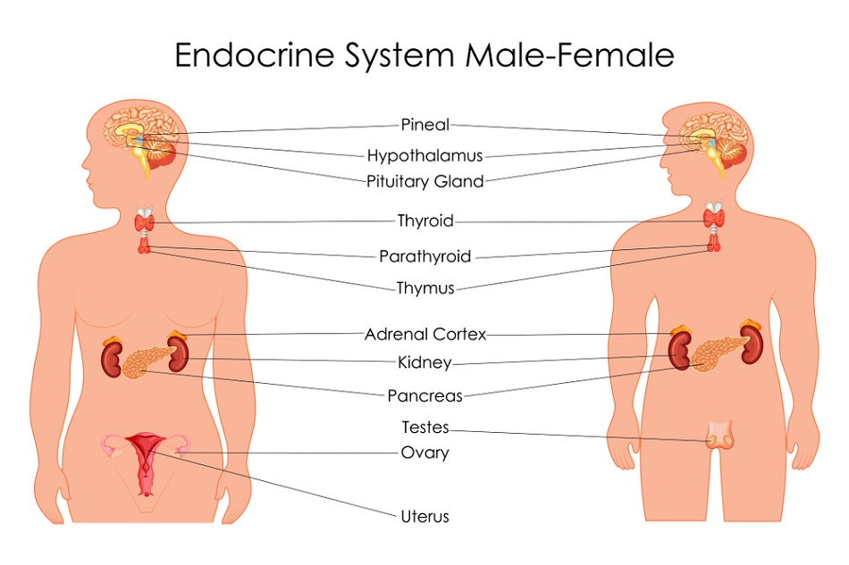**

**THE ENDROCRINE/DUCTLESS GLANDS**

**The following are the ductless glands**

|  |
| --- |
| 1. **Pituitary gland**   Pituitary gland is described as **master gland** because it controls the functioning of other endocrine glands in the body.  **Hormones produced by pituitary glands include the following**   1. **Oxytocin-** It stimulates rhythmic contractions of the uterine muscles during labour-parturition. It also causes expulsion of milk from mammary glands   **Effect of under-secretion of oxytocin hormone**  It makes birth to be delayed  **Effect of over-secretion of oxytocin hormone**  It causes premature birth.   1. **Anti-diuretic hormone (ADH)/vasopressin**   It is produced by hypothalamus in the pituitary gland  **Function**   * It controls water reabsorption in the kidney nephrons during urine production. It stimulates the kidney to absorb water. * It plays important role in osmoregulation, keeping the volume of blood and the osmotic potential of the body fluids constant. It stimulates the walls of the collecting ducts and diastal convulated tubule to be more permeable to water. More water is reabsorbed from glomerular filtrate back to the blood. This restores blood water level back to normal. When ADH is produced in less quantity, an individual suffers a condition called **Diabetes insipidus.**  1. **Prolactin-** It brings about lactation thus production and secretion of milk by the mammary glands soon after a woman has given birth. In other words, it stimulates milk production in lactating mammals. 2. **Follicle Stimulating Hormone (FSH)-** It stimulates the growth of follicles cells in the ovaries in females. It also stimulates the leyding cells to secret testosterone for sperm production in males. 3. **Adrenocorticotropic hormone-** It regulates the secretion of steroid hormones from the cortex of adrenal glands. 4. **Luteinizing Hormone-** It brings about ovulation 5. **Thyrotrophin-** It stimulates thyroid gland to secrete thyroxine hormone 6. **Somatotrophin-** It promotes growth and metabolic functions. It also stimulates growth of cartilage, bone and muscle tissue and also deposition of minerals for example calcium in bone tissue.   Low secretion of Somatotrophin leads to dwarfism and over-secretion may lead to giantism   1. **Thyroid Stimulating Hormone-** It regulates the secretion of the hormone thyroxine from the thyroid gland. 2. **Melanophore Stimulating Hormone-** It brings about expansion of melanin pigment 3. **Thyroid gland-** This gland produces **thyroxine hormone.** This hormone is comprised of iodine.Its secretion is controlled by Thyroxin Stimulating Hormone produced by Pituitary gland.   **Function of thyroxine hormone-** It controls the metabolic rate in all the  cells of the body including the rate of glucose metabolism in the cells.  **Effects of thyroxin under-secretion**   * **Cretinism**-It results in retarded skeletal growth and mental development in children. * **Myxoedema**- results in fat accumulation in the skin in adults. Sluggishness and mental slowness.   **Adrenal glands-** TheyIt produces adrenaline hormone. The function of adrenaline hormone is that it t prepares the body for emergency. It also stimulates high rate of respiration to produce more energy.  It is therefore sometimes referred to as the **fright hormone, emergency hormone or combat hormone.**  The hormone is involved in response to danger, anxiety, excitement and emergency.   1. **Pancreas-** It contains Islets of langerhan cells that secrete insulin hormone**.**  * The Function of insulin hormone is that it promotes conversion of excess glucose in the blood into glycogen in the body. Glycogen is stored in the liver. Insulin decreases glucose concentration in the blood if the concentration rises above normal. It also increases use of glucose to eliminate excess glucose in the blood. * The other function of the insulin hormone is that it stimulates conversion of excess glucose to lipids that are then stored by the body.   **Effect of deficiency of insulin production**  If the pancreas produces insufficient insulin, an individual suffers from a disease called **diabetes mellitus or sugar disease.**  Therefore, diabetes milletus is a condition in which the pancreas fails to produce insulin if produces inadequate amounts of insulin. A person with diabetes mellitus an abnormally high level of glucose in the blood.  **Symptoms of diabetes mellitus**   1. Passing out urine frequently 2. Constantly feeling tasty. 3. Dehydration 4. Loss of weight 5. Poor resistance to infections  * The islets of langerhan cells of pancreas also produce **glucagon hormone.** * The function of the glucagon hormone is that it increases concentration of glucose in blood. It stimulates the liver to convert glycogen into glucose when the level of glucose in blood is low.  1. **Testes-** They produce **testosterone hormone.**   The function of Testosterone hormone is that it promotes secondary sexual characteristics in males- It also promotes growth and development of reproductive organs.   1. **Ovaries-** They produce oestrogen hormone. The function of oestrogen hormone is that it promotes development of reproductive organs and secondary sexual characteristics infemales. |

**DIFFERENCES BETWEEN ENDOCRINE AND NERVOUS SYSTEMS**

|  |  |
| --- | --- |
| **Endocrine system** | **Nervous system** |
| Uses chemical substance or hormones to relay impulses. | Uses electrical charges caused by concentration of chemical substance to relay impulse. |
| Hormones are transmitted through the blood. | Impulses are transmitted through nerve fibres. |
| Hormones reach all parts of the body. | Never impulses are transmitted through nerve cells connected to specific parts of the body. |
| Hormones stay longer in the blood and as a result, their effects last longer. | Impulses are short-lived and as a result, their effects last for a short time. |
| Mostly involved in growth responses and some muscle activity. | Mostly involved in muscles contractions and stimulation of hormone secretion. |
| Responses are usually slow**.** | Responses are usually fast. |

**CHAPTER FIVE -IMMUNITY**

**What is immunity?**

|  |
| --- |
| Immunity is the ability of the body to defend itself against infectious agents, foreign cells and even abnormal cells such as cancer. |

**TYPES OF IMMUNITY**

|  |
| --- |
| **Two types of immunity are**   1. **Natural immunity (innate/inborn)**   Natural immunity is the immunity that comes from within the body itself.  **Two types of natural immunity are**   1. **Active (infection) natural immunity** - This is the type of immunity that develops after recovering from a disease. The body produces antibodies very quickly after recovering from the diseases to make the body immune if the disease attacks the organism again. 2. **Passive (placenta) natural immunity**- This immunity acquired by the foetus from the mother by getting antibodies against pathogens through the placenta also through breast milk. 3. **Artificial immunity(adaptive)**   Artificial immunity is the immunity that is obtained by introducing antigens into the body of an organism to protect the organism to protect the organism from a disease.  **Types of artificial immunity**   1. **Artificial acquired active immunity**- It is the protection produced by intentional exposure of a person to antigens in a vaccine, so as to produce an active and lasting immune response. The antigens in the vaccine stimulate the immune system the immune system to produce antibodies and memory cells which are specifically directed against the antigens in the vaccine. 2. **Passive artificial immunity-** It is the transfer of immunity in the form of ready-made antibodies, that is, using antibodies produced in one organism to protect another organism from a specific disease. |

**FIRST LINE OF DEFENSE AND HOW IT WORKS**

|  |
| --- |
| These are natural ways through which the body fights against infection. The first line of defense prevents the entry of germs or pathogens into the body.  **The first line defense/external defense mechanism include**  C:\Users\new\AppData\Local\Temp\WPDNSE\{00000008-0001-0001-0000-000000000000}\5438851_orig.gif   1. **Skin**   The skin creates a barrier that protects the cells inside the body from harmful microorganisms in the external environment. In other words, the human skin forms water-proof, germ -proof and self-repairing barrier.   1. **Mucus lining of respiratory tract**   The mucus that that is produced by mucus membranes in the lining of all body openings trap the germs and dust breathed in together with air through the nose or mouth so that they do not reach the lungs. The trapped germs and dirty are then carried by cilia to the gullet where they are swallowed and eventually passed out of the body through faeces.  The cilia in the nasal cavity and trachea trap dirt and germs and they are coughed out or sneezed out.   1. **Acids in the stomach/digestive system**   The hydrochloric acid produced by the stomach kills bacteria that come into the stomach with food.   1. **Tears**   Tears produced by tears glands keep the eye moist and clean away dust or any foreign particle or chemicals reaching the conjunctiva. The tears also contain a substance called lysonzyme that kills any germ that might enter the eye   1. **Earwax**   The wax produced by Sebaceous glands trap and kills the bacteria and fungi entering the ear. The wax also traps dust and keeps off insects from entering the ear canal.   1. **Vaginal secretions**   They slightly acidic that inhibits growth of pathogens   1. **Symbiotic defense**   Symbiotic is a relationship whereby two organisms live together and benefit from each other. For example, bacteria benefits from food, warmth and shelter from the baby. On other hand, the bacteria make vitamin K that is used by the baby. The bacteria also fight other bacteria that may enter the intestine to cause disease.   1. **Interferon**   These are protein compounds produced by cells which have been invaded by viruses, blocks the transcription of new viral early proteins to prevent the infection   1. **Blood clotting**   Blood clotting is the mechanism that prevents blood loss from the broken vessels. When blood vessel is broken, platelets or damaged cells release chemical substance known as **prothrombin** into the blood plasma and causing the production of enzyme **Thrombin**. **Thrombin** turns the soluble plasma **fibrinogen** into its insoluble fibrous form **Fibrin**. **Fibrin** binds together platelets and blood cells to form a **clot** at the site of the wound. When a clot is formed, it blocks further loss of blood and prevents microorganism entering the body through the point of injury. This reduces chances of infection.  C:\Users\new\AppData\Local\Temp\WPDNSE\{00000008-0001-0001-0000-000000000000}\58f52d5901672aeca9179c11be28087c.jpg  . |

**SECOND LINE OF DEFENSE/INTERNAL DEFENSE MECHANISM**

|  |
| --- |
| It is the natural immunity that become into operation when the germ has gained entry into the body after the first line of defence has been defeated.  The second line of defence is provided by the **action of the phagocytes** and **the action of lymphocytes/antibodies.**   1. **Action of the phagocytes**   Phagocytes are white blood cells which destroy germs by engulfing and digesting them in the blood and tissues. Other phagocytes are attached to walls of lymph nodes where they destroy germs in the lymph. The diagrams below represent phagocytes.     1. **Action of lymphocytes/antibodies**   Lymphocytes are white blood cells that produce antibodies which destroy, disintegrate or inactivate pathogens.  The following are the types of lymphocytes   1. **B-lymphocytes**   They produce antibodies that destroy germs by either dissolving them or neutralizing them.   1. **T-lymphocytes**   They either attack pathogens directly or produce chemicals which coordinate the activity of all cells in the immune system.   1. **T-helper cells**   They are middlemen in the immune response. When they get activated, they secrete cytokines that regulate or help effectors lymphocyte function. HIV attack T-helper cells.  **HOW T-CELLS WORK**  **T-cells** are a subset of lymphocytes that play a large role in the immune system response. T stands for thymus, the organ in which their final stage of development occurs.   1. **Cytotoxix T-cells** destroy infected cells. These cells function as “killer” because they are able to destroy target T-cells which express specific antigens that they recognize. These cells are important in fighting viral infections and tumours. They are able to find and then destroy cells infected with a virus or a cancerous cell. Cytotoxic or T-killer cells do their work by releasing lymph toxins which cause celllysis. 2. **T-helper cells-** They are middlemen in the immune response. When they get activated, they secrete cytokines that regulate or help effectors lymphocyte function. 3. **Regulatory T-cells/Suppressor T-cells**- They suppress activation of the immune system and maintain immune system homeostasis. Failure of regulatory T- Cells to function properly may result in autoimmune diseases in which the immunocytes attack cells in the body. |

**IMMUNISATION**

|  |
| --- |
| Vaccination is the process of acquiring or inducing resistance to infection in a human being. In other words, immunization is the process of making a person immune to an antigen by giving a vaccine to make the person immune to a disease**.**  The following are the purposes of vaccination/immunization   1. To initiate the production of antibodies. 2. To initiate the mobilization of lymphocytes and macrophanages in a process called cellular immune response. |

**ABO BLOOD GROUPS**

|  |
| --- |
| * ABO blood groups are the most basic system of blood typing. It is the classification of human blood based on the inherited properties of red blood cells as determined by the presence or absence of the antigens A and B which are carried on the surface of the red blood cells. * Red blood cells of Type A have the A antigen on their surface, those of the type B have antigen B, type AB red blood cells bear both antigens A and B while type O cells bear neither antigen as shown in figure below. * Blood containing red cells with type A antigen on their surface has its serum antibodies against B (Ant- B) red cells. If in blood transfusion, type B blood is injected into persons with type A blood, the red cells in the injected blood will be destroyed by the antibodies in the recipient’s blood since there will agglutination. * Blood containing red cells with type B antigen on their surface has its serum antibodies against A (Anti -A) red cells. If in blood transfusion, type A blood is injected into persons with type B blood, the red cells in the injected blood will be destroyed by the antibodies in the recipient’s blood since there will agglutination. * Blood that does not red cells with type A antigen and type B antigen ( blood group) on their surface has its serum antibodies against A (Anti -A) red cells and antibodies against B (Ant- B). If in blood transfusion, type O blood is injected into persons with type A, B or O blood, the red cells in the injected blood will be NOT BE destroyed by the antibodies in the recipient’s blood. Hence no agglutination. **Blood group O** is the **universal donor** since the person with is blood group can donate blood to all other blood groups. * Persons with type AB can receive type A, B or O blood since it does not have antibodies in their blood plasma. Blood AB is t he universal recipient since can receive blood from all other blood groups.   This system divides blood into four groups -A, B, AB and O.    **Take note:**   * Antibodies are found in the blood plasma * Antigens are found on the surface of red blood cells. |

**BLOOD COMPATIBILITY**

**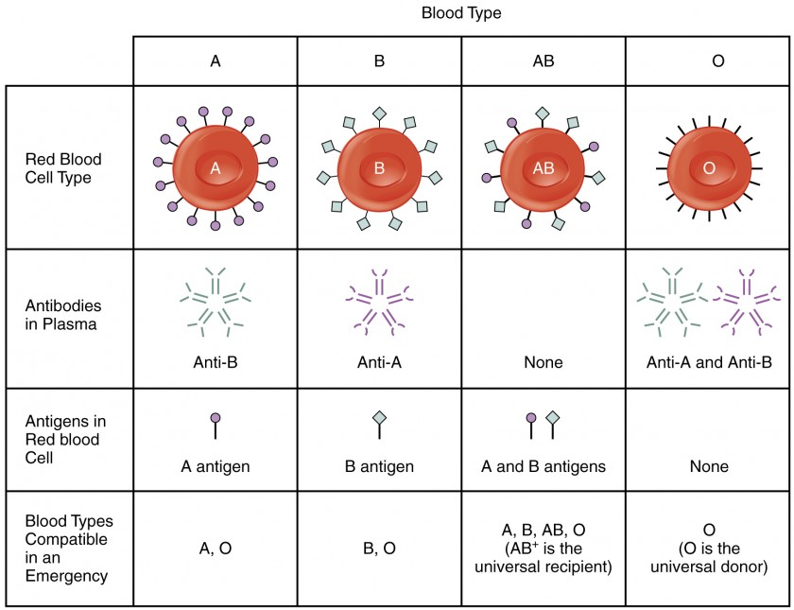**

**UNIVERSAL DONOR**

|  |
| --- |
| Individuals with type O blood do not produce antigens. Therefore, their blood normally will not be rejected when it is given to others with different ABO types**.** A s a result, type O people are universal donors for blood transfusions but they can receive only type O blood themselves |

**UNIVERSAL RECEIPIENT**

|  |
| --- |
| Individuals with type AB blood group do not make any ABO antibodies. Their blood does not discriminate against any other ABO type. Consequently, they are universal receivers for blood transfusions, but their blood will be agglutinated when given to the people with every other type because they produce both kinds of antigens. |

**TESTING BLOOD COMPARTIBILITY & INCOMPARTIBILITY**

|  |
| --- |
| It is easy and inexpensive to determine an individual’s ABO type from a few drops of blood. A **serum** containing **Anti- A antibodies** is mixed with some of the blood. Another serum with anti- B antibodies is mixed with the remaining sample. Whether or not agglutination occurs in either sample indicates the ABO type. It is a simple process of elimination of the possibilities. For instance, if an individual’s blood sample is agglutinated by anti-A antibody, but not the anti-B antibody, it means that the Anti-A antigen is present but not the anti-B antigen. Therefore, the blood types is A.  The table below shows the results for the test of blood groups. It shows where agglutination has occurred or not |

**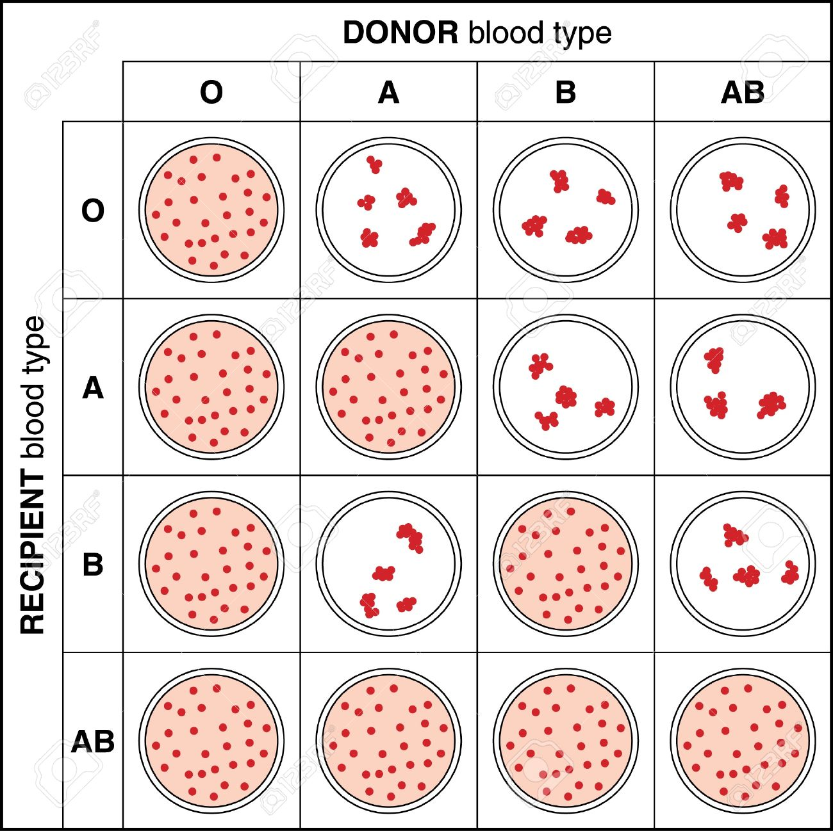**

**FACTORS TO CONSIDER BEFORE BLOOD TRANSFUSION**

|  |
| --- |
| 1. **Blood groups-** toavoid sticking together of red blood cells called agglutination. 2. **Rhesus factor-** to avoid miscarriage to pregnancies**.** 3. **HIV/AIDS** - to prevent transmission**.** 4. **Presence of hepatitis B - to avoid infection.** 5. **Syphilis- to avoid infection** 6. **Test for haemoglobin- To avoid oxygen short supply which may lead to death.** 7. **Blood pressure -test-** To avoid deaths that may occur due **to lower blood pressure.** 8. **Age of the donor us-** the blood donor too young 9. **Hepatitis**- Blood from individuals suffering from hepatitis should not be used for transfusion because virus can be transmitted through blood**.** |

**THE REPRODUCTIVE SYSTEM**

**Define the term reproduction.**

|  |
| --- |
| Reproduction ensures the continuation of similar kinds of species, generation after generation |

**TYPES OF REPRODUCTION**

|  |
| --- |
| 1. **SEXUAL REPRODUCTION**   This is the type of reproduction that involves the fusion of male and female gametes to form a zygote through which a full organism develops. The male gametes produced by testes are known as sperms while the female gametes produced by ovary are known as ova or eggs.  In the first step of reproduction is the fusion of a sperm and an ovum. The process of the fusion of a sperm and an ovum is known as fertilization. During the fertilization, the nuclei of the sperm and the egg fuse together and form a single nucleus that results into the formation of the fertilized egg also known as zygote through which a new full organism develops.   1. **ASEXUAL REPRODUCTION**   This is the type of reproduction in which only a single parent gets divided into two new offspring’s. Examples include **Hydra** and **Amoeba**  In Hydra, the individuals develop the buds, therefore, this type of asexual reproduction is known as budding. It shown below  In amoeba, nucleus gets divided into two nuclei; therefore, such kind of asexual reproduction is known as binary fission. The figure below shows binary fission in the amoeba. |

**HUMAN MALE REPRODUCTIVE SYSTEM**

|  |
| --- |
| C:\Users\new\Desktop\CHIVANGA\cbse_class_10_imp_bio_diagram10.jpg |
| 1. **Testis:**  * Sex organ that produces sperm in a process called **spermatogenesis** , and male sex hormones (**testosterone**). * Each testis contains about 250 functional units called lobules; each lobule contains about 4 **seminiferous tubules** where spermatogenesis occurs.  1. **Accessory sex glands** 2. **Seminal vesicles:** secrete an alkaline solution that makes up 60% of the semen volume; this seminal fluid contains fructose (nutrient for the sperm) and prostaglandins (substances that stimulate uterine contraction during sexual excitation). 3. **Prostate gland:** secretes a slightly acidic, milky white fluid that makes up about 30% of semen volume; this fluid helps neutralize the pH of semen and vaginal secretion. 4. **Bulb urethral gland:** secretes a clear lubricating fluid that aids in sexual intercourse. 5. **Urethra:** A tubule located inside the penis for urine excretion and semen ejaculation .Contains smooth muscle that performs rapid peristalsis during ejaculation . 6. **Penis:** A copulatory organ that is responsible for delivering the sperm to the female reproductive tract. Contains 2 erectile tissues called **corpus cavernosa** and **corpus spongiosum** , where the latter one enlarges and forms the glans penis due to increased blood flow during sexual excitation |

**HUMAN FEMALE REPRODUCTIVE SYSTEM**

|  |
| --- |
| C:\Users\new\Desktop\CHIVANGA\cbse_class_10_imp_bio_diagram11.jpg   1. **Ovary**   The ovaries serve two purposes   1. They produce eggs(ova) 2. They secrete oestrogen and progesterone hormones which regulate the maturation of eggs and help in producing bodily changes during puberty. 3. **Oviduct/fallopian tube**   These are tubes leading from the ovaries to the uterus.  **Functions of fallopian tube**   1. They are important for transmitting eggs from the ovary to the uterus/passage for the ovum to the uterus. They are adapted for this function because they are lined up with cilia hairs that push the ovum towards the uterus. 2. They are site for fertilization and initial development of the baby 3. **Uterus**    * + 1. Prepare for implantation and development of the embryo        2. Under the stimulation of oxytocin, contracts during labor to expel the fetus into the vagina 4. **Cervix**   The base of uterus is closed by a narrow passageway called **cervix** to prevent the entry of foregin substances   1. **Vagina**   The vagina is a muscular hollow tube that extends from the vagina opening to the uterus.  It has muscular walls which can allow it to expand and contract.  The vagina’s muscular walls are lined with mucous membranes which keep it protected and moist.  **Functions of the vagina**  The vagina serves three purposes:   1. for copulation(It’s where the penis is inserted during sexual intercourse) 2. It’s the pathway (the birth canal) through which a baby leaves a woman’s body during childbirth 3. It’s the route through which menstrual blood leaves the body during periods (allowing menstrual blood to leave the body). |

**THE STRUCTURE/CHARACTERISTICS OF THE SPERM**

|  |
| --- |
| Sperms are gametes or sex cells that are produced in the testes of male human beings and animals.  Like a female gamete, sperm carries a total of 23 chromosomes that are produced as a result of a process known as meiosis.  A sperm cell consists of a head, body and a tail. Each of these parts is equipped with various molecules and smaller structure that allow the sperm as a whole to function properly  C:\Users\new\AppData\Local\Temp\WPDNSE\{00000008-0001-0001-0000-000000000000}\Schematic-diagram-of-the-structure-of-mammalian-sperm.png  Sperm cells are gametes or sex cells which are produced in the testes of the male human beings and animals.  Like the female gametes, sperm carries a total of 23 chromosomes that are a result of a process known as meiosis. Both egg cells and sperm cells are involved in the sexual mode of reproduction.   1. **Nucleus**   It contains 23 chromosomes that determine the characteristics of the new organism once the sperm fuses with the ovum during fertilization.   1. **Head**   The head of the nucleus contains an enlarged haploid nucleus, the frontward part of which is enveloped by a cap-like structure, acrosome.  **Function of acrosome**  It contains enzymes that break up egg membrane so that the head  penetrate the ovum to allow fertilization   1. **Middle piece**   It contains tightly packed mitochondria that provide the energy requires for swimming.  The middle piece of the sperm is called power of sperm because it gives energy to the sperm to swim in the female genital tract.  **Function of mitochondria**  Numerous mitochondria are present in the middle piece of the sperm which creates energy for the movement of tail or flagellum.   1. **Tail**   **It is very long necessary for swimming or locomotion.**  **Function of the tail**  It is responsible for the vigorous movement of sperm towards ovum or it helps the sperm to swim in the female genital tract.   1. **Streamlined body shape**   The sperm has streamlined body that allows it to move rapidly to reach the target egg cell. The stream lined shape reduces the force of drag during movement   1. **Motility**- It is mobile. The sperm’s beats gently from one side to another as the cell moves along what may appear to be a straight path. |

**ADAPTATIONS OF THE SPERM FOR ITS FUNCTION**

|  |
| --- |
| 1. **It has streamlined body-** The sperm has streamlined body that allows it to move rapidly to reach the target egg cell. The stream lined shape reduces the force of drag during movement 2. **It has tightly packed mitochondria-** The middle piece of a sperm carries about 70 mitochondria which creates energy required for locomotion. 3. **The tail**- It has very long tailresponsible for the vigorous movement of sperm towards ovum 4. **Acrosome**- It contains enzymes that break up or to digest egg membrane which helps promote fertilization 5. **It has haploid nucleus-** It allows it to form a diploid nucleus upon fertilization with an egg. |

**ADAPTATIONS OF THE SPERM FOR LOCOMOTION**

|  |
| --- |
| 1. **It has tightly packed mitochondria-** The middle piece of a sperm carries about 70 mitochondria which creates energy required for locomotion. 2. **The tail**- It has very long tailresponsible for the vigorous movement of sperm towards ovum |

**SPERM AND OVUM**

|  |
| --- |
|  |

**MAMMALIAN OVUM**

**DIFFERENCES BETWEEN MAMMALIAN SPERM & MAMMALIAN OVUM**

|  |  |
| --- | --- |
| **Sperm** | **Ovum** |
| Streamlined line body shape | oval shape |
| Has tail | No tail |
| Has head | No head |
| Has mitochondria in the middle piece | No middle and hence no mitochondria |
| It is mobile | Immobile |
| size - Smaller than the sperm | Bigger than the sperm. It contains food reserve |

**SIMILARITIES BETWEEN MAMMALIAN SPERM & MAMMALIAN OVUM**

|  |
| --- |
| Both have   1. Nucleus 2. cytoplasm 3. Cell membrane |

**MENSTRUAL CYCLE & ROLES OF HORMONES**

|  |
| --- |
| Menstruation is the shedding of the lining of the uterus accompanied by bleeding. It starts during puberty and permanently stops at menopause. It is 28 days cycle. It begins with the first day of bleeding which is counted as day 1.  Menstrual bleeding lasts 3 to 7 days, averaging 5 days.  Menstrual cycle is regulated by hormones which include   1. **Follicle Stimulating Hormone**   It is produced by the Pituitary gland  **Function**  It promotes the development of Graafian follicle cells in the ovary.   1. **Luteinizing Hormone**   It is produced by the Pituitary gland  **Function**   1. It causes ovulation 2. It causes the development of corpus luteum 3. **Oestrogen hormone**   It is produced by the ovaries  **Function**  It stimulates the thickening of the uterine walls or its is responsible for uterine lining development   1. **Progesterone hormone**   It is produced by corpus luteum in the ovary  **Function**  It maintains pregnancy by stimulating the thickness of the uterine wall after fertilization has occurred. It prepares the uterine lining for implantation.  Menstrual cycle has three phases   1. Follicular phase (before the release of the egg) 2. Ovulatory phase (egg release) 3. Luteal phase (after egg release)   **THE STAGES OF MENSTRUAL CYCLE**  The chart below illustrates the changes in a woman’s body during the menstrual cycle**.**     1. **Follicular phase (before lease of the egg)**   During this stage, the level of oestrogen and progesterone hormone decreases in the in the blood, and this causes menstruation. The decrease in the level of oestrogen and progesterone causes the top layers of the thickened uterus break down and are shed, and menstrual bleeding occurs.  During the same period, the pituitary gland produces Follicle Stimulating Hormone hence its level increases slightly in the blood. The secretion and its increase in the blood, stimulates the development of follicle cells in the ovary.  Each follicle contains an egg. Later in the stage, as follicle Stimulating Hormone level decreases, only one follicle continues to develop. This follicle produces **Oestrogen.**   1. **The ovulatory phase**   This stage begins with the increase in Luteinizing Hormone and Follicle Stimulating Hormone. The Luteinizing and Follicle Stimulating Hormone are at their peak in the middle of the cycle (14th day) and cause the rupture of Graafian follicle cells to release ovum. This phase is ovulatory phase.  The function of Luteinizing Hormone is to stimulate egg release (ovulation) which usually occurs 16 to 32 hours after the surge begins.  During this phase, the oestrogen hormone level decreases` and the progesterone level starts to increase.   1. **Luteal phase**   The remains of the Graafian follicles get converted into the corpus luteum that secretes progesterone for the maintenance of the uterine lining. During the luteal phase, Pituitary gland starts producing Luteininizing hormone and follicle Stimulating hormone which increase their levels in the blood. During this phase, the oesttrogen level is high. Progesterone and oestrogen cause the lining of the uterus to thicken more, to prepare for possible fertilization.  If the egg is not fertilized (in the absence of fertilization), the corpus luteum degenerates and no longer produces progesterone, the oestrogen level decreases, the uterus lining breaks down and are shed and menstrual bleeding occurs, the start of a new menstrual cycle.  If the egg is fertilized, the corpus luteum continues to function during early pregnancy. It helps maintain the pregnancy. |

**FERTILISATION/CONCEPTION**

|  |
| --- |
| C:\Users\new\AppData\Local\Temp\WPDNSE\{000030F6-0001-0001-0000-000000000000}\oogenesis and spermatogenesis[9].jpg  Fertilization is the fusion of male and female gametes to form a zygote. Fertilization occurs in the oviduct after the egg has been released from the ovary where it is produced.  During copulation, semen is liberated by the penis into the vagina. The mobile sperms swim swiftly and pass through the cervix and then enter into the uterus and finally reach the fallopian tube (oviduct). In this region, the fertilization takes place which occurs only when the ovum and sperms are transported simultaneously to the oviduct/fallopian tube. This is the reason that all copulations do not lead to fertilization and pregnancy.  The diagram below shows how fertilization takes place in the oviduct of the female reproductive system.    In other words, fertilization can be defined as the fusion of haploid male gamete (sperm) and a haploid female gamete (ovum) to form a diploid zygote   * Within an hour after sexual intercourse, sperm would have traveled from the vagina, through the cervix, into the uterus and uterine tube. During this journey, the **acrosome** on the head of spermatozoa would be worn off, releasing **acrosin** enzyme by the time sperm are attached to the outer coatings of the ovum. * The head of the penetrated sperm is now detached from its mid piece and tail . It will then rupture , releasing 23 chromosomes in the form of long strands of DNA molecules . * The chromosomes from the sperm and ovum now unite to form a complete set of genetic makeup for the offspring – 2 haploid cells   (Sperm and ovum) are now joined to become a single diploid celled **zygote.** Fertilization is now complete.  The fertilized egg divides to form an embryo. The embryo attaches to the lining of the uterus. It begins to develop into a foetus and finally into a baby.  **THE DEVELOPMENT OF FOETUS IN THE UTERUS**    The foetus relies upon its mother as it develops. It needs   1. protection against knock and bumps and temperature changes 2. Oxygen for respiration 3. Nutrients -food and water   The foetus is protected by the **uterus** and the **amniotic fluid**, a liquid contained in a bag called the **amnion.** |

**THE ROLE OF PLACENTA**

|  |
| --- |
| * The placenta is an organ responsible for providing oxygen and nutrients, and removing waste substances. * It grows into the wall of the uterus and is joined to the foetus by the umbilical cord. * The mother’s blood does not mix with the blood of the foetus but the placenta lets substances pass between the two blood supplies by diffusion. These include  1. Oxygen and nutrients diffuse across the placenta from the mother to the foetus. 2. Carbon dioxide and other waste substances diffuse across the placenta from the foetus to the mother.   The blood of the mother and foetus do mix but substances diffuse across the placenta**.** |

**THE STRUCTURE AND FUNCTIONS OF THE PLACENTA**

|  |
| --- |
| **Umbilical cord**  Function of the umbilical cord is that it is the passage of materials from the maternal blood to the foetal blood and vice versa through the placenta.  The umbilical cord is not directly connected to the mother’s circulatory system. Instead, it joins the placenta which transfers materials to and from the mother’s blood by diffusion without allowing direct mixing.  The umbilical cord contains two blood vessels   1. **The umbilical vein** carries oxygenated, nutrient rich blood from the placenta to the foetus. It has high concentration of oxygen, amino acids, glucose, vitamins and antibodies from the placenta to the foetus. 2. **The umbilical artery** carries deoxygenated nutrient depleted blood from the foetus to the placenta. It has concentration of carbon dioxide, urea but low concentration of glucose, amino acids and fatty acids |

**PREGNANCY**

|  |
| --- |
| * A zygote is formed about 12-24 hours after ovulation. This single cell, still the same size as the original ovum, continues to travel through the uterine tube toward the uterus by the action of cilia along the inner lining of uterine tube. * About an hour after fertilization is complete, mitotic cell division **occurs**, dividing the zygote into a cluster of smaller cells. * Soon after implantation , layers of membrane begin to form outside the embryo * Stimulates the corpus luteum in the ovary for the secretion of estrogens and progesterone, until the placenta is fully developed and can secrete estrogens and progesterone. * **Amnion** – the middle membrane that secretes amniotic fluid for nourishing the embryo and to act as the lubricants. * **Placenta** – the outermost membrane that protects the embryo and foetus, allows exchange of nutrients and wastes between foetal and maternal blood, and secretes estrogens and progesterone to maintain pregnancy * As the placenta develops, it secrets large quantities of estrogen and progesterone.   Placental estrogen and progesterone:   1. Stimulate the uterine lining to continue development. 2. Maintain the uterine lining. 3. Inhibit secretion of FSH and LH from the Ant. pituitary gland. 4. Stimulates development of the mammary gland. 5. Inhibit uterine contractions (progesterone). 6. Enlarge the reproductive organs (estrogen). |

**FACTORS CONTRIBUTING TO LABOR PROCESS**

|  |
| --- |
| * As the time of birth approaches, secretion of progesterone declines, and its inhibiting effect on uterine contractions may lessen. * Decreasing progesterone concentration may stimulate synthesis of prostaglandins, which may initiate labour. * Stretching uterine tissues stimulates release of oxytocin from the Pituitary gland. * Oxytocin may stimulate uterine contractions and aid labor in its later stages. * As the foetal head stretches the cervix, a positive feedback mechanism results in stronger and stronger uterine contractions and a greater release of oxytocin. * Positive feedback stimulates abdominal wall muscles to contract with greater and greater force. * The fetus is forced out through the birth canal to the outside. |

**THE IMPORTANCE OF BREAST FEEDING**

|  |
| --- |
| Breast milk   * + Has perfect nutrients   + Is easily digested;   + Is efficiently used   + Protects against infection   **Breastfeeding**   * + Helps bonding and development   + Helps delay a new pregnancy   + Protects mothers’ health   + Costs less than artificial feeding   **Psychological benefits of breastfeeding**   1. **Emotional bonding**    * Close, loving relationship between mother and baby    * Mother more emotionally satisfied    * Baby cries less    * Baby may be more emotionally secure 2. **Development**    * Children perform better on intelligence tests   **Benefits for baby**   * + 1. Breast milk is the most complete form of nutrition for infants. A mother's milk has just the right amount of fat, sugar, water, and protein that is needed for a baby's growth and development. Most babies find it easier to digest breast milk than they do formula.     2. As a result, breastfed infants grow exactly the way they should. They tend to gain less unnecessary weight and to be leaner. This may result in being less overweight later in life.     3. Premature babies do better when breastfed compared to premature babies who are fed formula.     4. Breastfed babies score slightly higher on IQ tests, especially babies who were born pre-maturely.   **Benefits for mother:**   * Nursing uses up extra calories, making it easier to lose the pounds of pregnancy. It also helps the uterus to get back to its original size and lessens any bleeding a woman may have after giving birth. * Breastfeeding, especially exclusive breastfeeding (no supplementing with formula), delays the return of normal ovulation and menstrual * Breastfeeding lowers the risk of breast and ovarian cancers, and possibly the risk of hip fractures and osteoporosis after menopause. * Breastfeeding makes your life easier. It saves time and money. You do not have to purchase, measure, and mix formula. There are no bottles to warm in the middle of the night! * A mother can give her baby immediate satisfaction by providing her breast milk when her baby is hungry. * Breastfeeding requires a mother to take some quiet relaxed time for herself and her baby. * Breastfeeding can help a mother to bond with her baby. Physical contact is important to newborns and can help them feel more secure, warm and comforted. * Breastfeeding mothers may have increased self-confidence and feelings of closeness and bonding with their infants. |

**Colostrums**

|  |
| --- |
| **Property of colostrums and its importance**  • Antibody rich - protects against allergy & infection  • Many white cells - protects against infection  • Purgative - clears meconium  - helps to prevent jaundice  • Growth factors - helps intestine to mature  - prevents allergy, intolerance  • Rich in Vitamin A - reduces severity of infection |

**Disadvantages of artificial feeding (bottle feeding)**

|  |
| --- |
| * Interferes with bonding * More diarrhoea and persistent diarrhoea * More frequent respiratory infections * Malnutrition; Vitamin A deficiency * More allergy and milk intolerance * Increased risk of some chronic diseases * Obesity * Lower scores on intelligence tests * Mother may become pregnant sooner * Increased risk of anaemia, ovarian cancer, and * breast cancer in mother |

**CONTRACEPTIVE METHODS- BIRTH CONTROL**

|  |  |  |  |  |
| --- | --- | --- | --- | --- |
| **Birth control** is a voluntary regulation of conception. **Contraception** is any method used in birth control to prevent fertilization of the ovum.  The most common contraceptive methods and their success rate –   1. **Abstinence** is done by male and female where sexual intercourse is avoided.   **Advantages**   |  | | --- | | * Highly effective * No side effects, as with other methods * No cost * Can increase intimacy between partners |   **Disadvantages**   |  | | --- | | * May be difficult to abstain from all sexual activity for extended periods of time |  1. **Vasectomy** is done by male where the vas deferens tubes are cut to prevent sperm transport.      1. **Tubule ligation** is done by female where the uterine tubes are tied or cut to prevent ovum transport and passage of sperm. 2. **Birth control pills** is taken by female in which daily moderate level of estrogens suppress the ovarian and menstrual cycles. It prevents release of egg, and blocks sperm from meeting egg. Oral contraceptive pills should be taken one pill every day. They are most effective when no pills are missed, the pill is taken at the same time every day, and each new pack of pills is started without a delay     Advantages   1. Safe 2. Good method while breastfeeding      1. **Intrauterine Devices** (IUDS) (IUDs or IUCDs) are small, flexible plastic devices that are inserted into the woman’s uterus. The most common IUDs contain copper, and they work by preventing sperm from reaching an egg. The purpose of IUD is to prevent sperm from meeting the egg. Depending on the type, IUDs can provide protection for 5 to 12 years.     **Advantages**   1. Nothing to put in place before intercourse 2. Some do not change hormone levels 3. Some may reduce period cramps and make your period lighter. For some women, periods stop entirely 4. Can be used while breastfeeding 5. Can be used for an extended period of time (5 years and up) 6. The ability to become pregnant returns quickly once IUD is removed   Disadvantages   1. Large initial cost 2. Some IUDs can cause hormonal side effects similar to those caused by oral contraceptives, such as breast tenderness, mood swings, and headaches 3. **Condom** used by male or female is impermeable to sperm during ejaculation. Barrier methods are either devices (male and female condoms) that physically block sperm from reaching an egg, or chemicals (spermicides) that kill or damage the sperm in the vagina. The effectiveness of barrier methods greatly depends on people’s ability to use them correctly every time they have sex.   **Male condom Female condom**    **Advantages of male condom**   * Prevents both pregnancy and sexually transmitted infections including HIV/AIDS * Effective when used correctly every time you have sex * Condoms also could prevent the transmission of sexually transmitted diseases].   **Advantages of female condom**   1. Female-controlled 2. More comfortable to men, less decrease in sensation than with the male condom 3. Offers protection against STIs (covers both internal and external genitalia) 4. Can be inserted before sex 5. Stronger than latex   **Disadvantages of female condom**   1. Not aesthetically pleasing 2. Can slip into the vagina or anus during sex 3. Difficulties in insertion/removal 4. Not easy to find in drugstores or other com­mon sources of condoms 5. Higher cost than male condoms 6. **Diaphragm and / or foam** is used by female block the entrance of sperm into the cervix. 7. **Withdrawal method (or coitus interrupts)** is done by male in which the penis is withdrawn from the vagina before ejaculation occurs.     **Advantages**   1. No supplies 2. No side-effects 3. Can be used at any time   **Disadvantage**  Not as effective as other methods   1. **Rhythm method (75%)** is done by female where sexual intercourse is performed only before ovulation and about a week after ovulation occurs, there are three ways to time ovulation. Fertility awareness methods require a couple to know the fertile days of the woman’s menstrual cycle — the days when pregnancy is most likely to occur. During these fertile days the couple must avoid sex or use a barrier method to prevent pregnancy. 2. **Norplant**   Contraceptive implants are inserted under the skin of a woman’s upper arm and provide continuous, highly effective pregnancy protection for 3 to 5 years, depending on the type of implant. Hormones from the tubes blocks sperm from reaching egg and prevents release of egg. When this time is over, new implants can be inserted during the same visit that the old set is removed.    **Advantages**   |  | | --- | | 1. Do not have to take every day 2. Progestin only-no estrogen related side-effects Safe to use 3. Lasts up to 3 years |  1. Safe to use 2. One of the most effective methods  * Can be removed any time if you want to get pregnant   **Disadvantages**   |  | | --- | | * Insertion may be uncomfortable (The implant is a small flexible rod that is in­serted right under the skin of the inner arm.) * Progestin-related side effects   • Large initial cost |  1. **Female sterilization**  * Specially trained provider makes one or two small cuts to reach the tubes that carry eggs to the womb. Cuts or blocks the tubes. The womb is not removed. Can be done right after you have a baby as well as other times.   Female and male sterilization are permanent methods of contraception. Sterilization involves a relatively simple surgical procedure that provides life-long protection against pregnancy. Sterilization is appropriate for men and women who are certain they do not want more children. |

**PROBLEMS ASSOCIATED WITH REPRODUCTION**

1. **Sexually transmitted diseases (STDS)**

|  |
| --- |
| Formerly called venereal diseases (VDs). They are bacterial or viral infections that are spread through sexual contact.  These include   1. **Gonorrhea**  * Caused by bacterium named *Neisseria gonorrhoeae*. Bacteria invade the mucosal layer of reproductive and urinary tracts. * Most common symptoms in male is urethritis (infection of urethra)**,** resulting in painful urination. * Symptoms in female include abdominal discomfort, vaginal discharge, and uterine bleeding. * Penicillin and tetracycline antibiotic drugs are effective, but sometimes bacteria might be resistant to these drugs.  1. **Syphilis**  * Caused by a bacterium named *Treponema pallidum* . It can be transmitted from mother to fetus where the fetus usually will be stillborn or die after birth. * Bacteria penetrate mucosal layer and skin easily, and enter into blood and lymph. * Incubation period is about 12 weeks, after which a red, painless lesion appears on external genitalia . * If untreated, pink skin rash will appear all over the body. Fever, joint pain, anaemia, hair loss will occur if still untreated. * Final stage of development occurs after a 10-years latent period – bacteria invade central nervous system, blood vessels, bones, skin, and other organs – which might lead to death. penicillin is the only known treatment , but only effective during early stages of symptoms   **5. Chlamydia**   * Caused by a bacterium named *Chlamydia trachomatis*. * Responsible for 25-50% of all pelvic inflammation. * Each year about 150,000 infants are born with the disease (in these cases, Chlamydia becomes a "congenital disease” where the fetus acquires the bacteria from mother's vagina during the birth process). * **Symptoms** are often unrecognized – urethritis , vaginal discharge , * Abdominal pain, painful urination and intercourse, and irregular menstruation. * Infants tend to develop pneumonia. * Treatment is tetracycline. |

1. Sterility
2. Fistula
3. Cervical cancer
4. Maternal death
5. Abnormal menses

**THE HUMAN LIFE CYCLE**

|  |
| --- |
| Humans use two types of cell division to ensure that DNA is passeddown from cell to cell during reproduction.  During mitosis a cell doubles its DNA before dividing into two cells.  In meiosis, the chromosomes in a gamete cell are reduced by half. |

**MITOSIS**

|  |
| --- |
| * Mitosis is a nuclear division of the ordinary cell that results in the production of diploid daughter cells. In other words, mitosis is a process where a single cell divides into two identical daughter cells. * Mitosis is a type of cell division in which one cell (the mother) divides to produce two new cells (daughter cells) that are genetically identical to itself. * Mitosis is described as somatic cell division because it occurs in soma cells (ordinary cells) * The figure below shows mitosis process. * Diploid daughter cells are the cells that contain full number of chromosomes of the parent cell. |

**FUNDAMENTAL FEATURES OF MITOSIS**

|  |
| --- |
| The following are the fundamental features of mitosis:   * + - Involves one cell division     - Results in two daughter cells     - Results in diploid daughter cells- chromosome number remains as the same as parent cell.     - Daughter cells are genetically identical.     - Occurs in all organisms except viruses     - Creates all body cells-somatic cells apart from the gametes     - Prophase is much shorter     - No recombination/crossing over occurs in prophase.     - In metaphase individual chromosomes -pairs of chromatids line up along the equator.     - During anaphase the sister chromatids are separated to opposite poles. |

**STAGES OF MITOSIS PROCESS**

|  |
| --- |
| **Mitosis occurs in five stages:**   * 1. **Interphase:** the start of mitosis, the DNA of each chromosome replicates. Each chromosome then reorganizes into paired structures called sister chromatids, with each member of the pair containing a full copy of the DNA sequence.   2. **Prophase:** the sister chromatids condense, thickening until they appear joined at a single site, known as the centromere.   3. **Metaphase**: the sister chromatids line up in the middle of the cell.   4. **Anaphase**: the chromatid pairs split apart at the centromere, and each half of the pair then moves toward opposite poles of the cells.   5. **Telophase:** the final stage of mitosis, a nuclear membrane forms around the chromosomes at each pole of the cell.   + Mitosis ends with the formation of two new cells, each with a matching full set of chromosomes.   + The cytoplasm divides; the cell membrane pinches inward ultimately producing two daughter cells (**Cytokinesis**). |

**MEIOSIS (REDUCTION CELL DIVISION)**

|  |
| --- |
| * Meiosis is a process where a single cell divides twice to produce four cells containing half the original number of chromosomes of that of parent cell. * Meiosis is described as **reduction cell division** because it reduces the chromosome number of the parent cell to half in the daughter cells. * The figure below shows meiosis process |

**STAGES OF MEIOSIS**

|  |
| --- |
| **Meiosis comprises two successive nuclear divisions.**  **FIRST DIVISION OF MEIOSIS**:   * 1. **Prophase I:** Each chromosome duplicates and remains closely associated. These are called sister chromatids.   2. **Metaphase I**: Homologous chromosomes align at the equatorial plate.   3. **Anaphase I**: Homologous pairs separate with sister chromatids remaining together.   4. **Telophase I**: Two daughter cells are formed with each daughter containing only one chromosome of the homologous pair.   **SECOND DIVISION OF MEIOSIS**:   * 1. **Prophase II**: DNA does not replicate.   2. **Metaphase II**: Chromosomes align at the equatorial plate.   3. **Anaphase II**: Centromeres divide and sister chromatids migrate separately to each pole.   4. **Telophase II**: Cell division is complete. Four haploid (n) daughter cells are obtained.   Meiosis ensures that reproduction will produce a zygote that has  received one set of chromosomes (n) from each parent to form |

**FUNDAMENTAL FEATURES MEIOSIS**

|  |
| --- |
| 1. Involves two successive cell divisions 2. Results in four daughter cells 3. Results in haploid daughter cells which have the chromosome number is halved from the parent cell. 4. Daughter cells are genetically different 5. Occurs only in animals, plants and fungi 6. It produces gametes (eggs and sperms) only 7. Prophase 1 takes much longer 8. Involves recombination/crossing over of chromosomes in prophase 1. 9. During anaphase 11 the sister chromatids are separated to opposite poles. |

**SIMILARITIES BETWEEN MITOSIS AND MEIOSIS**

|  |
| --- |
| * Have diploid parent cell * Both consists of interphase, prophase, metaphase, anaphase and telophase stages * Both in metaphase individual chromosomes (pairs of chromatids) line up along the equator. * Both during anaphase the sister chromatids are separated to opposite poles. * Ends with cytokinesis. |

**FUNDAMENTAL DIFFERENCES BETWEEN MITOSIS AND MEIOSIS**

|  |  |
| --- | --- |
| **MITOSIS** | **MEIOSIS** |
| Involves division of body(soma) cells | Involves division of sex cells |
| Division of a cell occurs once | Division of cell occurs twice |
| Produces two daughter cells | Produces four daughter cells |
| Produces diploid cells | Produces haploid cells |
| Daughter cells are genetically identical | Daughter cells are genetically different |

**CHROMOSME NUMBER**

**How do you calculate chromosomes of the ordinary cell or the gamete of an organism?**

|  |
| --- |
| * Diploid cell has 2n chromosomes while the haploid has n chromosomes. * Given the number of the ordinary cell of an organism divide by 2 to get the number of chromosomes found in its haploid cells (gametes). * Given the number of chromosomes in the gamete of an organism, to find the number of chromosomes in the diploid cell or ordinary cell, you have to multiply the number of chromosomes found in the gamete (haploid cell) by 2. * The number of chromosomes does not correlate with the apparent complexity of animal or a plant. * In humans, for example, the diploid number is 2n = 46 (that is 23 pairs). The sperm of a man has 23 chromosomes or an ovum has also 23 chromosomes half of the diploid cell. This means that the haploid cell has half the chromosomes of the diploid number of the chromosomes. * The ordinary cell of a dog has 78 pairs of chromosomes and its gamete (an egg or sperm has 39 chromosomes. |

**THE STRUCTURE AND FUNCTIONS OF THE CHROMOSOMES**

|  |
| --- |
| Chromosomes are threadlike structure molecules that carry hereditary information (carrying genetic information in the form of genes) found in the nucleus of most living cells, Chromosomes contribute to the division of cells and they are of prime importance as they carry the genes which are the hereditary material.  Each chromosome consists of protein substance known as Deoxyribonucleic Acid (DNA) which contains an organism’s genetic instructions passed down from parents.  During cell division, each DNA strand is duplicated and the chromosomes condense to become visible as distinct pairs of chromatids joined at the centromere.  The figure below shows the chromosomes.    DNA is protein molecule found in the chromosome that encodes all the information every cell needs.  Humans have 23 pairs of chromosomes. The human being’s ordinary cell has 23 pairs of chromosomes and 46 chromosomes in total in the ordinary cell.  Twenty two pairs, the autosomes, are the same in either sex and are numbered from 1- 22. The 23rd chromosome pair is called the sex chromosome, this chromosome pair consists of two X chromosomes in women, and men have one X + one Y chromosomes.  During fertilization, gametes from the sperm combine with gametes from the egg to form a zygote. The zygote contains sets of 23 chromosomes for the required 46 chromosomes. |

**GENETICS & INHERITANCE**

|  |
| --- |
| * Genetics is the study of heredity and variations.   Heredity refers to the genes inherited from parents by the off springs through the gametes which are not influenced by the environment  Genetics is the study of the principles of **heredity and variation**. A unique genetic code is found in the DNA of each organism and is passed on to the offspring during reproduction. Since there are **two parents** required for sexual reproduction, **genetic variation** will occur to ensure survival of the fittest. Variation refers the difference in characteristics or phenotype within a species caused by genetics and environmental factors.  **The Role of Gametes in Inheritance**     * DNA molecules on the chromosomes consist of sections called **genes** * Each gene contains the hereditary **traits,** e.g. skin and hair colour, height, body structure and blood group are represented by the genes on each of the two homologous chromosomes. * **What is a trait?** A **trait** is a characteristic that can vary from one individual to the next (e.g., eye color) * During the process of Meiosis, **haploid** gametes are produced and the gametes will contain one set of genes * During fertilization, the gametes fuse and a **diploid zygote** results * One set of genes will come from the female parent (maternal) and one set from the male parent (paternal) |

**MENDEL’S THREE LAWS.**

|  |
| --- |
| * + - 1. **Law of Dominance**   When two homozygous individuals with one or more sets of contrasting characters are crossed, the characters that appear in the F1 hybrids are dominant characters and those do not appear in F1 are recessive characters.  The **Principle of dominance states that** some alleles are dominant and others are recessive.  **Dominant** traits are expressed if only one allele is present. (Capital letter, first letter of trait ex. **Tall= T)**  **Example -** Tall allele **(T)** is dominant and short allele is recessive **(t).If the tall plants are crossed bred with short plants all F1** generation will be tall even though Tt. Both **TT and Tt** plants are Tall    **Law of Segregation**  Law of Segregation states that the hereditary factors (genes) making up a pair are separated out during the time of gamete formation, that is, only one factor or gene of each pair goes into a given gamete.  In other words, the Law of Segregation states that when any individual produces gametes, the copies of a gene separate, so that each gamete receives only one copy. A gamete will receive one allele or the other.  This principle is also known as **Law of purity of *gametes*,** because gametes are always pure for a given pair. They have only one gene(factor) of each pair.  See the diagram below    Mendel stated that each individual has two factors for each trait, one from each parent. The two factors may or may not contain the same information.  If the two factors are identical, the individual is called **homozygous** for the trait.  If the two factors have different information, the individual is called **heterozygous**. The alternative forms of a factor are called **alleles**. The genotype of an individual is made up of the many alleles it possesses. An individual's physical appearance, or phenotype, is determined by its alleles as well as by its environment. An individual possesses two alleles for each trait; one allele is given by the female parent and the other by the male parent. They are passed on when an individual matures and produces gametes: egg and sperm. When gametes form, the paired alleles separate randomly so that each gamete receives a copy of one of the two alleles. The presence of an allele doesn't promise that the trait will be expressed in the individual that possesses it. In heterozygous individuals the only allele that is expressed is the dominant. The recessive allele is present but its expression is hidden.  **Example 1**  In the cross between Red flowered and White flowered plants, the F1 plants possess factors for both Red and White flower colours. But during gamete formation, they got separated. Some of the gametes will have factor or gene 'R' while other have r.  Example 2  Pure tall plants are homozygous and, therefore/possess genes (factors) TT; similarly dwarf possess genes tt. The tallness and dwarfness are two independent but contrasting factors or determiners. **Pure tall plants** produce gametes all of which possess gene **T** and dwarf plants t type of gametes.  During cross fertilization gametes with **T** and t unite to produce hybrids of F1 generation. These hybrids possess genotype **Tt**. It means **F**1 plants, though tall phenotypically, possess one gene for tallness and one gene for dwarfness. Apparently, the tall and dwarf characters appear to have become contaminated developing only tall character. But at the time of gamete formation, the genes **T (for tallness)** and **t (for dwarfness)** separate and are passed on to separate gametes. As a result, two types of gametes are produced from the heterozygote in equal numerosity. 50% of the gametes possess **gene T** and other 50% possess **gene t**. Therefore, these gametes are either pure for tallness or for dwarfness. (This is why the law of segregation is also described as Law of purity of gametes).  Gametes unite at random and when gametes are numerous all possible combinations can occur, with the result that tall and dwarf appear in the ratio of 3 :1.   * + - 1. **Law of Independent assortment**   The Law of Independent Assortment, also known as **"Inheritance Law"**, states that alleles of different genes assort independently of one another during gamete formation. |

**MENDELIAN DEVIATION**

Mendelian deviations or exceptions or anomalies includes

* 1. **Incomplete dominance**

|  |  |  |  |  |  |  |  |  |  |  |  |  |  |  |  |  |  |  |  |  |  |  |  |  |  |  |  |  |  |  |  |  |
| --- | --- | --- | --- | --- | --- | --- | --- | --- | --- | --- | --- | --- | --- | --- | --- | --- | --- | --- | --- | --- | --- | --- | --- | --- | --- | --- | --- | --- | --- | --- | --- | --- |
| * It is the situation in which both alleles do not display a dominant trait over the other resulting in a fine combination. * **Incomplete Dominance** (**Blending Inheritance)**-The hybrid does **not** resemble either parent but instead is a blend of parental traits. * Genes show incomplete dominance when the heterozygous phenotype is intermediate. * In cases of incomplete dominance, the inheritance of a dominant and a recessive allele results in production of intermediate characteristics. Mendel always observed complete dominance of one allele over the other for all the seven characters, which he studied, in garden pea. * **For example**, four-o’clock paint plants may have red, white, or pink flowers. Plants with red flowers have two copies of the dominant allele **R** for red flower color (**RR**). Plants with white flowers have two copies 16 of the recessive allele **r** for white flower color (**rr**). Pink flowers result in plants with one copy of each allele (**Rr**). * A cross between red and white flowered plants produced plants with intermediate flower colour i.e. pink colour in F1 and a modified ratio of 1 red: 2 pink: 1 White in F2.   **INCOMPLETE DOMINANCE**    **C:\Users\new\AppData\Local\Temp\WPDNSE\{000030F6-0001-0001-0000-000000000000}\unnamed.gif**  **Parents Red flower x White flower**  **RR x ww**    The above diagram is well illustrated by the punnet squares below  **Parents Pink flower x Pink flower (self-pollinated)**  **Rw x Rw**   |  |  |  |  |  | | --- | --- | --- | --- | --- | | Genotypes |  | RR | | F1 offsprings | |  | gametes | R | R | | ww | w | Rw | Rw | | w | Rw | ww |   F1 Rw pink flower  **Parents (F1) Pink flower x Pink flower (F1 X F1)**  **Rw x Rw**   |  |  |  |  |  | | --- | --- | --- | --- | --- | | Genotypes |  | Rw | | F2 offsprings | |  | gametes | R | R | | Rw | R | RR | Rw | | w | Rw | ww |   F2 1 Red (Rr) **:** 2 Pink (RR) **:** 1 White (rr) |

**COMPLETE DOMINANCE**

|  |
| --- |
| Mendel always observed complete dominance of one allele over the other for all the seven characters, which he studied, in garden pea.  A cross between red and white flowered plants produced plants with intermediate flower colour i.e. pink colour in F1 and a modified ratio of 1 red: 2 pink: 1 White in F2. See the diagram below    In case of codominance both alleles express their phenotypes in heterozygote greater than an intermediate one. The example is AB blood group in human. The people who have blood type AB are heterozygous exhibiting phenotypes for both the IA and IB alleles. In other words, heterozygotes for codominant alleles are phenotypically similar to both parental types.  The main difference between codominance and incomplete dominance lies in the way in which genes act. In case of codominance both alleles are active while in case of incomplete dominance both alleles blend to make an intermediate one. |

**Example of co dominance inheritance**

|  |
| --- |
| Co dominance is a form of inheritance wherein the alleles of a gene pair in a heterozygous are fully expressed. As a result, the phenotype of the offspring is a combination of the phenotype of the parents. Thus, the trait is neither dominant nor recessive.  Inheritance of blood groups, blood groups are determined by three types of genes, Genes A, B and O but genes A and B are both dominant genes and gene O is a recessive gene.  In case of codominance both alleles express their phenotypes in heterozygote greater than an intermediate one. The example is AB blood group in human. The people who have blood type AB are heterozygous exhibiting phenotypes for both the IA and IB alleles. In other words, heterozygotes for co-dominant alleles are phenotypically similar to both parental types.  The main difference between co- dominance and incomplete dominance lies in the way in which genes act. In case of co-dominance both alleles are active while in case of incomplete dominance both alleles blend to make an intermediate one. |

* 1. **Lethal genes etc**.

|  |
| --- |
| Gene, which causes the death of its carrier when in homozygous condition, is called lethal gene.  Mendel’s findings were based on equal survival of all genotypes. In normal segregation ratio of 3:1 is modified into 2:1 ratio. Lethal genes have been reported in both animals as well as plants.  In mice allele for yellow coat colour is dominant over grey. When a cross is made between yellow and grey a ratio of 1:1 for yellow and gray mice was observed. This indicated that yellow mice are always heterozygous. Because yellow homozygotes are never born because of homozygous lethality. Such genes were not observed by Mendel. He always got 3:1 ratio in F2 for single gene characters.  Lethal genes can be recessive, as in the aforementioned mouse experiments. Lethal genes can also be dominant, conditional, semilethal, or synthetic, depending on the gene or genes involved. See below |

**MONOHYBRID CROSS**

|  |  |
| --- | --- |
| * A cross is made between two true-breeding parents differing for a single trait, producing an F1 generation. These plants are intercrossed to produce an F2 generation. * A cross is made between two true-breeding parents differing for a single trait, producing an F1 generation. These plants are intercrossed to produce an F2 generation * A monohybrid cross is a genetic mix between two individuals who have homozygous genotypes or genotypes that have completely dominant or completely recessive alleles which result in opposite phenotypes for a certain genetic trait. * Monohybrid crosses are used by geneticists to observe how the offspring of homozygous individuals express the **heterozygous** genotypes they inherit from their parents. Typically this mix determines the dominant **genotype**. * A monohybrid cross can also signify a genetic mix between two individuals who have heterozygous genotypes. These crosses confirm the dominance of an **allele**.   **EXAMPLE 1**   |  | | --- | | **EXAMPLE 2** | |

**THE TESTCROSS**

|  |
| --- |
| Test cross is used as a tool to find out the genotype of the unknownindividual. For example, a Red flowered plant may be either homozygous [RR] orheterozygous [Rr], Its genotype can be determined by test cross. The Red flowered plantof unknown genotype is to be crossed with a White flowered plant If we get only Redflowered plants among the offsprings in F2, the Red parent plant is homozygous If weget both Ted flowered and White flowered plants among the offsprings, the Red floweredparent plant is heterozygous.  Because some alleles are dominant over others, the phenotype of an organism does not always reflect its genotype. A recessive phenotype (yellow) is only expressed with the organism is homozygous recessive (gg). A pea plant with green pods may be either homozygous dominant **(GG)** or heterozygous (**Gg)**. To determine whether an organism with a dominant  phenotype (e.g. green pod color) is homozygous dominant or heterozygous, you use a ***testcross*.**  The breeding of an organism of unknown genotype with a homozygous recessive. If all the progeny of the testcross have green pods, then the green pod parent was probably homozygous dominant since a **GG x gg** cross produces **Gg** progeny. If the progeny of the testcross contains both green and yellow phenotypes, then the green pod parent was heterozygous since a **Gg x gg** cross produces **Gg** and **gg** progeny in a 1:1 ratio. The testcross was devised by Mendel and is still an important tool in genetic studies. |

**BACK CROSSES**

|  |
| --- |
| In Mendelian inheritance, the F2 offsprings are obtained by self-pollinating the F1 hybrids. But the F1 hybrids can be crossed with either of the two parents of the parental generation. **Such crosses between F1 individuals [Rtf and theirparents [RR] or [rtf** **are known as Back crosses** |

**DOMINANT AND RECESSIVE GENES**

|  |
| --- |
| **Dominant** – It is an allele that masks the presence of a recessive allele in the phenotype. Dominant alleles for a trait are usually expressed if the individual is homozygous dominant or heterozygous.  **Recessive** – allele whose phenotypic expression is “hidden” when a dominant allele is present  **Hybrid** – offspring from a cross between two “pure” lines of different, competing phenotypes  **Dominant trait:** A heterozygous offspring will display the dominant trait because it will **dominate** over the other recessive gene of the allele pair, e.g.: red colour will **dominate over** the gene for white colour, so the offspring will look red.  **Dominant traits** are shown with a capital letter and Recessive traits are shown with a lower case letter  The **dominant allele** is always written with a capital letter: **R** = red and the recessive is written in lower case **r** = white.  **Homozygous dominant alleles** means that both genes are the **same** for the same dominant trait. It will be represented by **RR,** which represents both the genes for red flowers. The offspring will be red because **two dominant genes** are present.  **Heterozygous alleles** means that **one gene is dominant** and **one gene is recessive** for the same trait, e.g. red flowers. It will be represented by **Rr,** which represents one gene for red and one gene for white. The offspring will display red flowers, because red is **dominant** over white.  Mendel discovered that by crossing white flower and purple flower plants, the result was not a hybrid offspring. Rather than being a mix of the two, the offspring was purple flowered. He then conceived the idea of heredity units, which he called "factors", one which is a recessive characteristic and the other dominant. Mendel said that factors, later called genes, normally occur in pairs in ordinary body cells, yet segregate during the formation of sex cells. Each member of the pair becomes part of the separate sex cell. The **dominant gene**, such as the purple flower in Mendel's plants, will hide the **recessive gene**, the white flower.  After Mendel self-fertilized the F1 generation and obtained **the 3:1 ratio**, he correctly theorized that genes can be paired in three different ways for each trait; **AA, aa, and Aa**. The capital **A** represents the dominant factor and lowercase **a** represents the recessive. |

**GENOTYPE**

|  |
| --- |
| **Genotype** is the genetic make up of an individual. In other words, genotype is the genetic makeup of an organism, a description of the genes it contains. The genotype of an individual is made up of the many alleles it possesses.  **Gene** – unit of heredity; controls a trait that determines a phenotype, **Locus** – the location of a particular gene on a chromosome. **Alleles** – alternative versions of a gene  **HOMOZYGOUS AND HETEROZYGOUS**  Mendel stated that each individual has two factors for each trait, one from each parent. The two factors may or may not contain the same information.  If the two factors are identical, the individual is called **homozygous** for the trait.  If the two factors have different information, the individual is called **heterozygous**.  **Homozygous** means to have **2 identical** alleles for a trait. Ex. TT or tt True-breeding pea plants are homozygous.  **Heterozygous** means to have **2 different** alleles for a trait. Ex. Tt Hybrid plants are heterozygous.  **Therefore, homozygous** are individuals carrying two identical alleles (RR or rr) while **heterozygous** are individual organisms bearing different alleles (Rr).  **Homozygous genotype-** This refers to a genotype carrying two dominant or two recessive alleles. One allele is inherited from the father and the other from the mother. Examples include AA, BB, RR, WW, aa, bb, nn etc  **Heterozygous genotype-** This refers to the genotype carrying one dominant and one recessive allele.Examples include Aa, Rr, Ww, Bb, Hh etc |

**PHENOTYPE**

|  |
| --- |
| P**henotype** is the physical appearance of the individual produced by the genotype in cooperation with the environment. In other words, **phenotype** is the characteristics that can be observed in an organism determined by interaction of genes and environment. An individual's physical appearance, or phenotype, is determined by its alleles as well as by its environment.  Phenotyoe refers to the physical traits that are observed in an organism which are the outcome of the expression of the genes of individuals.  Examples Sickle cell trait, Red flower, White flower etc  Genes provide potential, but environment determines whether that potential is realized. |

**DIFFERENCES BETWEEN HOMOZYGOUS & HETEROZYGOUS**

|  |  |
| --- | --- |
| **Homozygous** | **Heterozygous** |
| Consists of two copies of same allele that codes for particular trait. | Consists of two different copies of alleles that code for a particular trait. |
| Consists of either allele pairs but not both | Consists of both dominant and recessive allele |
| Self-breeding results in the same traits over generations | Self-breeding results in the combination of traits. |
| Produces a single gamete | Produces two types of gametes |
| The two types are homozygous dominants and homozygous recessive | The three types of heterozygous alleles complete dominance, incomplete dominance, and co dominance. |

**DIFFERENCES BETWEEN GENOTYPE AND PHENOTYPE**

|  |  |
| --- | --- |
| **Genotype** | **Phenotype** |
| It refers hereditary information of the organism in the form of gene in the DNA and remains the same throughout the life | It refers to the visible characteristics of an organism**.** |
| Same genotype produces same phenotype | Same phenotype may or may not belong to same genotype |
| Present inside the body as genetic material | Expression of genes as the external appearance |
| It is inherited from the parent to the offspring. | It is not inherited from the parent |
| It can be determined by scientific methods. | It can be determined by observing the organism |
| It is affected by genes | It is affected by genotype and environmental conditions. |

**MONOHYBRID CROSSES & GENOTYPIC & PHENOTYPE RATIOS**

* + **P generation (or P1)** = parental generation
  + **F1 generation** = first generation offspring (from *filial*)
  + **F2 generation** = second generation offspring

**EXAMPLES**

1. A hozygous dominant red flower is crossed with a homozygous recessive white flower. Write down the genotypes of the parent, gametes, and F1 offsprings. What are the phenotypes of the F1 offsprings.

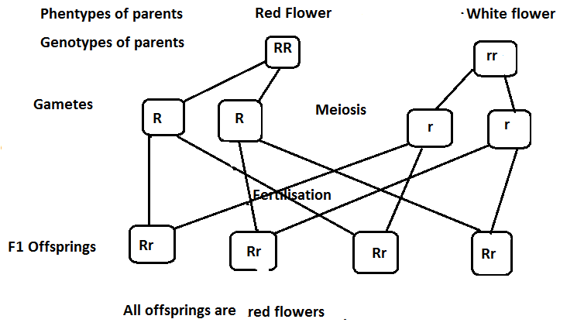

1. If the F1 offsprings were self-pollinated, what would be the genotypic and phenotypic ratios of the F2 offsprings? Show the workings.

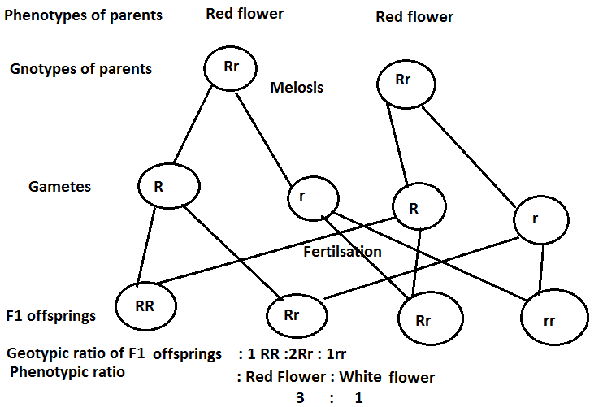

A hozygous dominant rounded seed plant is crossed with a homozygous recessive wrinkled seededplant. All F1 offsprings are rounded seed plantys.

* + 1. What are the genotypes of the parent and F1 offsprings? Show your workings.

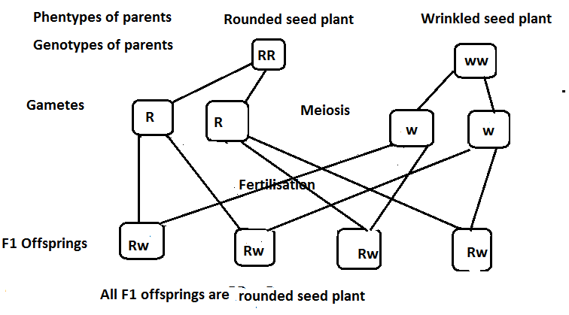

* + 1. If the F1 offsprings were self-pollinted, what would be the genotypic and phenotypic ratios of the F2 offsprings?

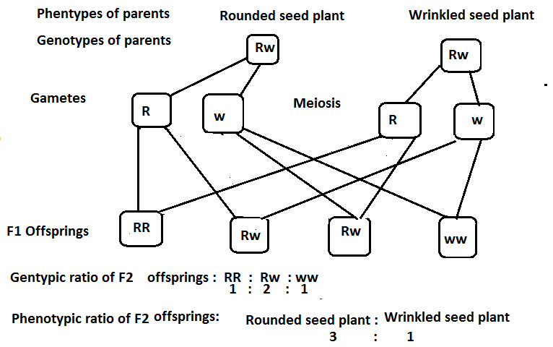

In guinea pigs, black fur (B) is dominant to white (b), cross Bb x bb and determine genotypic ratio for the offspring.

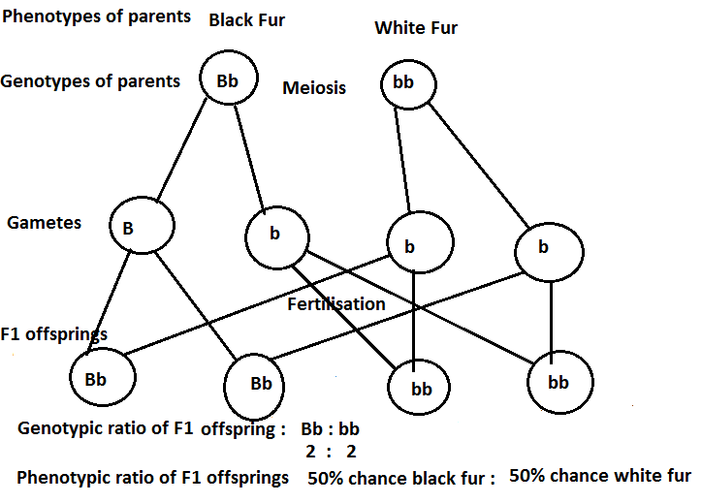

In pea plants, Tall stems (T) are dominant to short stems (t), cross a homozygous tall plant with a homozygous recessive plant, what are the genotypes and phenotypes of the F1 offsprings?

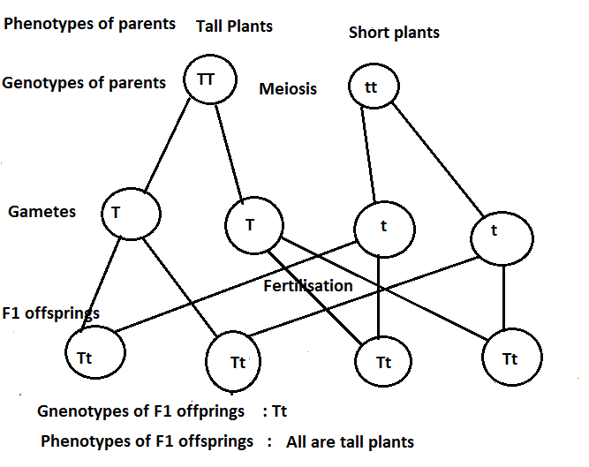

In plants, tall(T) is dominant to short (t) . Perform the followoing cross: Tt x Tt. What is the probality of producing short plant?

|  |
| --- |
| Phenotype Tall plants x Tall Plants  Genotypes Tt x Tt    Genotypes Phenotypes  TT Tall Plant  2 Tt Tall Plant  tt Short Plant $∴$ Phentypic ratio : 75% chance Tall : 25 % chance Short  Genotypic ratio 1 TT : 2 Tt : 1 tt  25% TT : 50% Tt : 25% tt |

In labrador retreivers the allele for a black coat colur (B) is dominant over the allele for a brown coat colour (b). If a brown labrador retriver is crossed with a heterozygous black labrador retriver, what will be genotypic ratio and phenotypic ratio of the F1 offsprings?

|  |  |  |
| --- | --- | --- |
| The Father must have Blood Type AB with genotype AB and the mother must have blood Type A with genotype AO to have the child with Blood Type B as shown the Punnett Square below | | |
| Gametes | O | 0 |
| A | AO | AO |
| B | BO | BO |
| **F1 Genotypes F1 Phenotypes**  2AO Blood Type A  2BO Blood Type B  Therefore, the mother’s genotype must be AO of Blood Type O in order to two children with Blood Types A and B and not to a child with Blood Type O. | | |

**INHERITANCE OF BLOOD GROUPS**

|  |  |  |  |  |  |  |  |  |  |  |  |  |  |  |  |  |  |  |  |  |  |  |  |  |  |  |  |  |  |  |  |  |  |  |  |
| --- | --- | --- | --- | --- | --- | --- | --- | --- | --- | --- | --- | --- | --- | --- | --- | --- | --- | --- | --- | --- | --- | --- | --- | --- | --- | --- | --- | --- | --- | --- | --- | --- | --- | --- | --- |
| Blood groups are inherited from our biological parents in the same way as eye colour and other traits.  Within the ABO Blood Group system, the A and B genes are co-dominant, that is, these will be expressed wherever the gene is present. The gene O is recessive and only expressed when neither A or B is present. Each biological parent donates one of the two genes ABO genes to their child.   |  |  |  |  |  | | --- | --- | --- | --- | --- | | **Genotype of blood group** | | **Condition** | | **Phenotype** | | **AA** | | **Homozygous** | | **Blood group A** | | **BB** | | **Homozygous** | | **Blood group B** | | **AB** | | **Heterozygous** | | **Blood group AB** | | **OO** | | **Homozygous** | | **Blood group** | | **AO** | | **Heterozygous** | | **Blood group A** | | **BO** | **Heterozygous** | | **Blood group B** | |   **C:\Users\new\AppData\Local\Temp\WPDNSE\{000030F6-0001-0001-0000-000000000000}\images (16).png** |

A woman with type A blood (genotype AO) is married to a type B person (genotype BO). Show the cross. What proportion of their children will have?

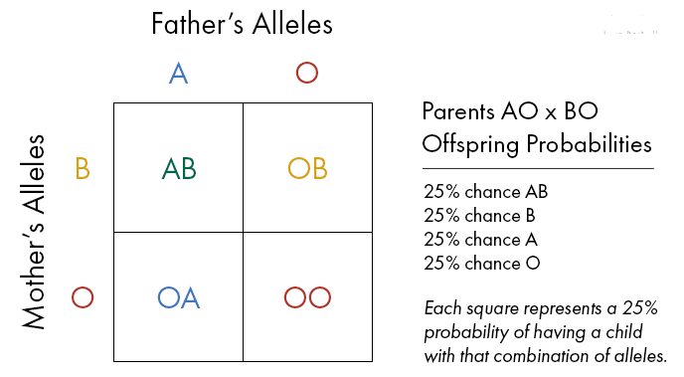

A man has type B blood (genotype BO) is married to a woman with type O blood. Show the cross. What proportion of their children will have?

|  |  |  |
| --- | --- | --- |
| The Father must have Blood Type AB with genotype AB and the mother must have blood Type A with genotype AO to have the child with Blood Type B as shown the Punnett Square below | | |
| Gametes | B | 0 |
| O | BO | OO |
| O | B0 | OO |
| **F1 Genotypes F1 Phenotypes**  2OO 50% chance Blood Type O  2B0 50% chance Blood Type B  Therefore, the mother of Blood Type O genotype and the father of Blood Type B with genotype (BO) can have 2 children with Blood Type O and 2 children of Blood Type B. | | |

A man with type A blood with genotype **(AO)** is married to a woman also with type B blood with genotype **(BO).** Show the cross. What proportion of their children will have?



A man with type AB blood is married to a woman also with type O blood. Show the cross. What proportion of their children will have?

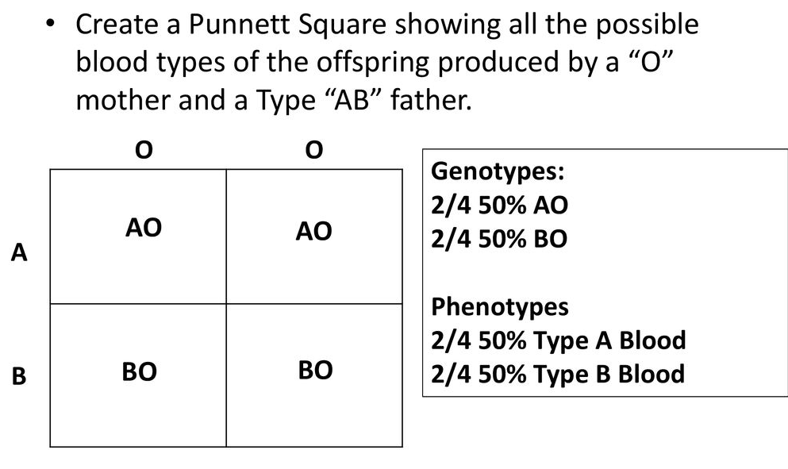

A woman with type A blood is claiming that a man with type AB is the father of her child who is type B. Show all the possible crosses. Could this man be the father of the child? How? Assuming that he is the father, what must the mother’s genotype be?

|  |  |  |
| --- | --- | --- |
| The Father must have Blood Type AB with genotype AB and the mother must have blood Type A with genotype AO to have the child with Blood Type B as shown the Punnett Square below | | |
| Gametes | A | 0 |
| A | AA | AO |
| B | AB | BO |
| **F1 Genotypes F1 Phenotypes**  AA Blood Type A  AB Blood Type AB  AO Blood Type A  B0 Blood Type B  Therefore, the mother’s genotype must be AO of Blood Type to hear a child with Blood Type B. | | |

A man with type AB blood is married to a woman with type O. They have two natural children and one adopted child. Jane has type A blood, Jordan has type B blood, and Marlin has type O blood. Which child was adopted? How do you know?

|  |  |  |
| --- | --- | --- |
| The Father must have Blood Type AB with genotype AB and the mother must have blood Type A with genotype AO to have the child with Blood Type B as shown the Punnett Square below | | |
| Gametes | O | 0 |
| A | AO | AO |
| B | BO | BO |
| **F1 Genotypes F1 Phenotypes**  2AO Blood Type A  2BO Blood Type B  Therefore, the mother’s genotype must be AO of Blood Type O in order to two children with Blood Types A and B and not to a child with Blood Type O. | | |

**SEX- DETERMINATION INHERITANCE**

|  |  |  |  |  |  |  |  |  |  |  |  |  |  |
| --- | --- | --- | --- | --- | --- | --- | --- | --- | --- | --- | --- | --- | --- |
| * Most chromosome pairs consist of identical (homologous) partners. * In humans, there is one pair of chromosomes in which the partners noticeably differ from each other. These are called the sex chromosomes because they determine the differences between males and females. * In human females, the sex chromosomes consist of two **X** chromosomes, while males have an **X** chromosome and a shorter **Y** chromosome with many fewer genes. * A male’s **X** chromosome may contain a recessive allele associated with a genetic disorder, such as hemophilia and red-green color blindness in humans. * Males do not have a normal second copy of the gene on the **Y** chromosome to mask the effects of the recessive gene, and disease typically results in the above cases. * Genes that are carried by either by either sex chromosome are said to be sex linked. Men normally have an X and Y combination of sex chromosomes while women have two X’s. Since only men inherit Y chromosomes, they are the only ones to inherit Y-linked traits.   **Sex Determination**  Somatic Cells-46 chromosomes/cell (23 Pairs)  44 Autosomes (22 Pairs)  2 Sex Chromosomes (1 Pair)  X chromosome-Female, Y Chromosome-Male   * XX-Normal Female, XY-Normal Male   Normal female   |  |  |  |  | | --- | --- | --- | --- | | Normal male | Gametes | X | X | | X | XX | XX | | Y | XY | XY | |  |  |  |   Genotypic ratio : 50% chance XX : 50% CHANCE XY  Phenotypic ratio: 50% Normal male : 50% Normal female  Female to Male ratio should be the same however it is not; **106 Males:100 Females**-The **Y** chromosome is smaller and lighter in weight then the **X** chromosome. **Y** sperm can swim slightly faster then the **X** sperm so more **Y** sperm will reach the egg. There is a somewhat better chance that the **Y** sperm will fertilize the egg. |

**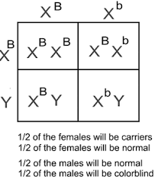**

**GAMETE FORMATION**

|  |
| --- |
| **Crossing over** is the exchange of genetic material between homologous chromosomes that results in recombinant chromosomes during sexual reproduction. Happen during prophase I This will guarantee that **all gametes are different.** |

**ABNORMAL GAMETE FORMATION**

|  |
| --- |
| Non-Disjunction- Failure of chromosome pairs to separate during Gamete formation |

**INHERITANCE OF SICKLE CELL ANAEMIA**

|  |
| --- |
| Sickle cell trait is caused by the recessive gene, ${Hb}^{s}$, that is responsible for the abnormal haemoglobin and gene $, {Hb}^{A}$ is responsible for normal haemoblobin.  The abnormal haemoglobin is when the red blood cell become hard and sticky and look like a C-shaped farm tool called a “sickle.” The sickle cells die early, which causes a constant shortage of red blood cells. This leads them to transport insufficient oxygen due to small surface area for transporting oxygen.  **Sickle cell trait (SCT)**  Sickle cell trait (SCT) is not a disease, but having it means that a person has inherited the sickle cell gene from one of his or her parents. People with SCT usually do not have any of the symptoms of sickle cell disease (SCD) and live a normal life.  **How Does Someone Get Sickle Cell Trait?**  People who have inherited one sickle cell gene and one normal gene have SCT. This means the person won’t have the disease, but will be a trait “carrier” and can pass it on to his or her children.  **Sickle Cell Trait**- Both types of cells, greater resistance to Malaria  **Sickle Cell Disease**  SCD is a genetic condition that is present at birth. In SCD, the red blood cells become hard and sticky and look like a C-shaped farm tool called a “sickle.” The sickle cells die early, which causes a constant shortage of red blood cells. Also, when they travel through small blood vessels, they get stuck and clog the blood flow. This can cause pain and other serious problems. It is inherited when a child receives two sickle cell genes—one from each parent. A person with SCD can pass the disease or SCT on to his or her children  **Sickle Cell Anemia**- Shortened Life span by approximately 50%  **What Are The Chances That A Baby Will Have Sickle Cell Trait**  If both parents have SCT, there is a 50% (or 1 in 2) chance •**•**that the child also will have SCT if the child inherits the sickle cell gene from one of the parents. Such children will not have symptoms of SCD, but they can pass SCT on to their children.  If both parents have SCT, there is a 25% (or 1 in 4) chance •**•**that the child will have SCD. There is the same 25% (or 1 in 4) chance that the child will not have SCD or SCT.  If one parent has SCT, there is a 50% (or 1 in 2) chance •**•**that the child will have SCT and an equal 50% chance that the child will not have SCT.  **Sickle Cell Disease ${Hb}^{A}$**  **= Normal haemoglobin ${Hb}^{s}$**  **= abnormal haemoglobin**    **Genotypic ratio = 1 : 2 :1**  **Phenotypic ratio = Normal: Sickle cell trait : Sickle cell anaemia**  **1 : 2 : 1**  **Sickle Cell Trait**- Both types of cells, greater resistance to Malaria  **Sickle Cell Anemia**- Shortened Life span by approximately 50%  **Sickle cell trait x normal** |
| **C:\Users\new\Desktop\Angela\76600b268da90d33c757b55d51dbd788f5aabdfb.png** |

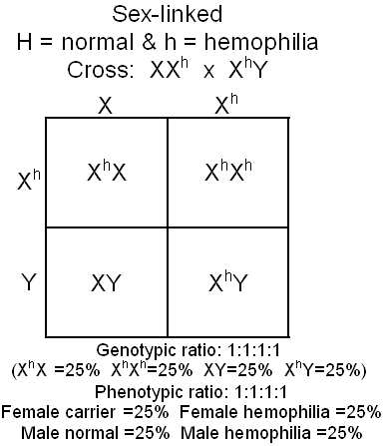

**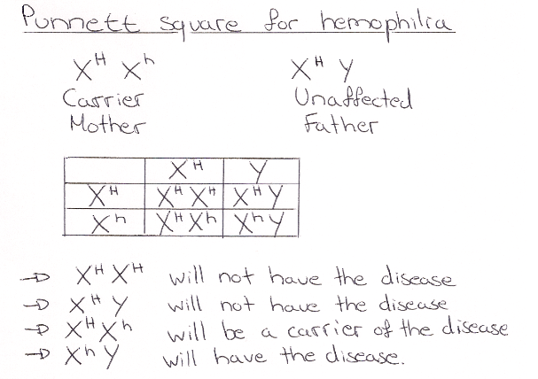**

**INHERITANCE OF ALBINISM**

|  |
| --- |
| Albinism is a group of inherited disorders that results in little or no production of the pigment melanin, which determines the colour of the skin, hair and eye colour.  Albinism is caused by a recessive gene but do not show signs and symptoms of the condition. The albino colour is controlled by a recessive gene (a) and the normal skin is controlled by a dominant gene (A). |

Albinism in humans is caused by a recessive allele *a*. From marriages between people known to be carriers (*Aa*) and people with albinism (*aa*). If both husband and wife are known to be carriers of the allele for albinism, what is the chance of the following combinations in a family of four children?

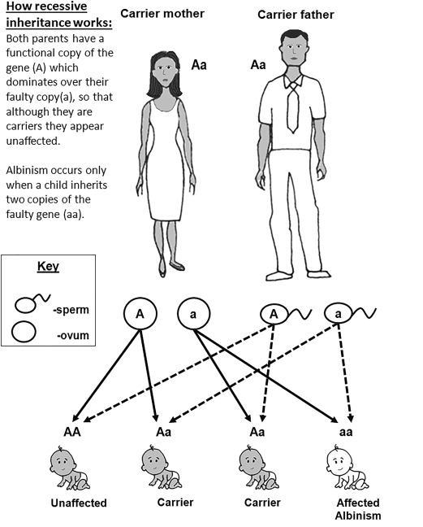

Albinism in humans is caused by a recessive allele *a*. From marriages between people known to be carriers (*Aa*) and people with albinism (*aa*), If both husband and wife are known to be carriers of the allele for albinism, what is the chance of the following combinations in a family of four children

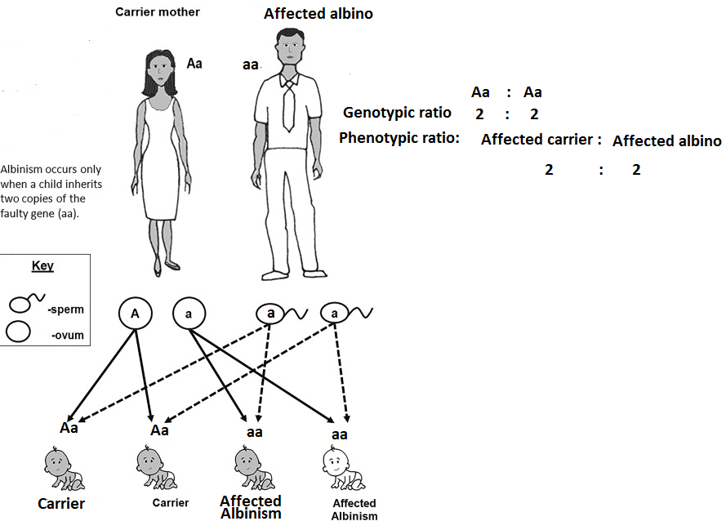

A researcher who has been studying albinism has identified a large group of families with four children in which at least one child shows albinism. None of the parents in this group of families shows albinism. Show by workings that a 3:1 phenotypic ratio would be expected on the basis of Mendel’s Principle of Segregation.

|  |
| --- |
| Genotypic ratio : AA : Aa : aa  1 : 2 : 1  Phenotypic ratio: Normal Brown skin : Albinism  3 : 1 |

**SEX LINKAGE (SEX LINKED TRAITS)**

|  |  |  |  |  |  |  |  |  |  |  |  |  |  |  |  |  |  |
| --- | --- | --- | --- | --- | --- | --- | --- | --- | --- | --- | --- | --- | --- | --- | --- | --- | --- |
| **Sex Linkage(sex linked traits) -** The genes for these traits are found only on the X chromosome, There are **NO** genes for this trait on the Y chromosome  **Color-blindness** (C-Normal color vision c-color blindness)  **Females**-Has XX therefore 2 genes **Males**-Has XY therefore 1 gene (on  the X chromosome)  CC-Normal Color Vision CY-Normal Color Vision  Cc-Carrier(Normal color vision but has the Cannot be a carrier gene to pass on)  cc-Color-blind cY-Color-blind   |  |  |  |  | | --- | --- | --- | --- | | Gametes | C | c | **Mother** | | C | CC-Normal Color Vision | Cc-Carrier | Females | | Y | CY-Normal Color Vision | cY-Color-blind | Males | | |  | | --- | | Father | |  |  |  | |

**HAEMOPHILIA**

|  |
| --- |
| **Haemophilia**-A condition in which the blood doesn’t clot and continues to bleed caused by the body not synthesizing factor VIII(8)-a step in the process of blood clotting  H-Normal Clotting h-Hemophilia  **Female Male**  HH-Normal HY-Normal  Hh-Carrier  hh-Hemophilia hY-Hemophilia  There have been virtually no cases(but still some) of Hemophilia in a Female because it is a rare gene and most people die at an early age from it |

**GENETICS AND ENVIRONMENT**

|  |
| --- |
| 1)Green Color in Plants-(C-Chlorophyl production c-No chlorophyl production)  **CC- Green Cc- Green cc-White (dead)**  **2)Baldness in Humans-(B-Bald b-Hair)**  Female Genotype Male A minimal level of testosterone  Hair BB Bald is needed to activate the dominant  Hair Bb Bald gene for baldness in Humans  Hair bb Hair |
| * . | |

**Explain the causes of variation.**

|  |
| --- |
| 1. **Heredity**   Heredity refers to the genes inherited from parents by the offspring through the gametes. During the formation of the zygote, a sperm cell from the father carries half the inherited material that is 23 chromosomes as the other half comes from the ovum. This simply explains why an offspring does not exactly resemble either the parent. This is a type of variation.   1. **Sexual reproduction**   During sexual reproduction, a zygote is formed by fusion of two cells from separate parents, male and female parents. This results to differences in characteristics of the off springs.   1. **Crossing over during meiosis**   This is the process in genetics by which the two chromosomes of a homologous pair exchange equal segments with each other. Crossing over occurs in the first division of meiosis. At that stage each chromosome has replicated into two strands called sister chromatics. The diagram below shows crossing over. During crossing over, maternal and paternal homologous chromosomes exchange segments with each other during prophase 1.  C:\Users\new\AppData\Local\Temp\WPDNSE\{00000008-0001-0001-0000-000000000000}\884166_orig.gif   1. **Independent assortment**. Mendel’s law of independent assortment states that the alleles of two or more different genes get sorted into gametes independently of one another. In other words, the allele a gamete receives for one gene does not influence the allele received for another gene. The diagram below shows independent assortment   **C:\Users\new\AppData\Local\Temp\WPDNSE\{00000008-0001-0001-0000-000000000000}\crossing_over.jpg**   1. **Random fertilization by gametes**   Random combining of gametes during fertilization produces various combinations of the variations already produced by the meiosis processes.   1. **Mutation-** Sudden changes in the structure and amount genetic material in the cells of an organism. Mutations cause changes in characteristics of an offspring. They can because by mutagens such as UV rays, cosmic rays and other chemicals. Mutations are passed on from generations to another 2. **Age -** Variation can be a result of emotional aspects that affect the muscles structure over long periods of life, effects of various hormones secreted by the body over a period of time, continues exposure to sun radiations , changes in diet and different life styles experienced at different times. |

**CAUSES OF MUTATIONS**

|  |
| --- |
| **The following are the causes of mutations**   1. Radiation   Exposure to X-ray radiation, alpha radiation, gamma radiation UV light and beta particles   1. Atomic energy 2. Rise in temperature 3. Chemicals |

**TYPES OF MUTATIONS**

|  |
| --- |
| 1. **Gene mutation**   Mutations that occur on genes. It is when part of DNA on a single chromosome is changed. This leads to the formation of defective protein or no protein formed at all.   1. **Chromosomal mutation**   Mutations that occur chromosomes. It occurs when cell division fails to work with complete accuracy. These are changes in the chromosome number or structure.  **Types of chromosomal mutations**   1. **Non- disjunction**   This occurs when homologous chromosomes fail to separate during anaphase 1 of meiosis. This leads to a situation where some daughter cells (gametes) carry more number of chromosomes while others carry fewer.  **Effects or non-disjunction disorders**   * Non-disjunction occurring in sex cells may lead to formation of gametes with extra chromosomes and others with fewer chromosomes in their nucleus. * In a successful fertilization involving such gametes then defective zygote are formed.   **Examples of effects or non-disjunction disorders**   1. **Down’s syndrome** 2. **Klinefelter** 3. **Chromosomal mutation** |

**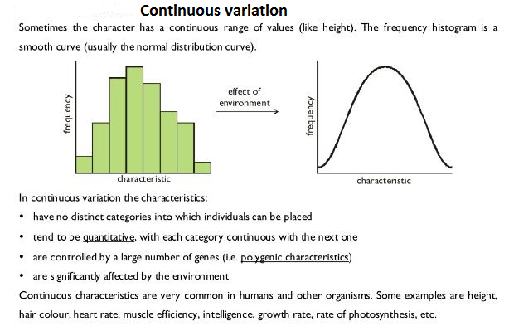**

**Differences between continuous variation and discontinuous variation**

|  |  |
| --- | --- |
| **Continuous variation** | **Discontinuous variation** |
| Deals a few genes | Deals with many genes |
| Deals with a few clear cut phenotypes | Deals with a spectrum phenotypes ranging from one extreme to the other |
| Genes do not show additive effect | Genes show additive effect, for example, the more ‘dark’ genes, the darker will be the skin colour. |
| Not modified by the environmental changes | Modified by environmental conditions such as greater exposure of the skin to sunlight will produce a darker skin colour. |

**CHAPTER SEVEN - EVOLUTION**

|  |
| --- |
| Evolution theory tries to explain how the great diversity of animals and plants that exist on earth today has come to be. It suggests that life on earth began from simple forms that then slowly evolved into the present day organisms. |

**SCHOOL OF THOUGHTS OF EVOLUTION**

|  |
| --- |
| **The following are the four theories that support evolution:**   1. **Creation Theory**   This is belief that life originate from the creator. Creation is the process by which something is brought into existence out of nothing**.** The theory is based on the idea that life was created by a supernatural being (God) at a particular time. According to the theory, creation occurred once and the organisms created have remained unchanged over time.   1. **Spontaneous Generation Theory**   Under this theory, people believe that life started as an abruptly bang. They hold that life started with the evolvement of oxygen gas from methane and hydrogen**.** They believed in life originating from non-living things. They hold that simple life of worm started from the rotten meat. The idea was disapproved; the worms were the maggot larvae.   1. **Lamarck’s Theory**   Lamarck theory is the notion that an organism can pass on to its offspring physical characteristics that the parent organism acquired though use or disuse during its life time. Jean Baptiste Lamarck proposed “The inheritance of acquired characteristics “. He proposed that organism’s effort s to efforts to adapt to the environment can be accumulated and passed on to their offspring. He further proposed that by using or not using its body parts, an individual tends to develop certain characteristics which it passes on to its offspring.      **EXAMPLES OF LAMARCK’S THEORY**  A giraffe acquired its long neck because its ancestor stretched higher and higher into the trees to reach leaves, and that the animal’s increasingly lengthened neck was passed on to its offspring.  C:\Users\new\AppData\Local\Temp\WPDNSE\{00000008-0001-0001-0000-000000000000}\1200-607791-8116585.jpg  **THE DEVELOPMENT OF LONG NECKS IN GIRAFFES**   1. **Darwin theory**   **State Darwin theory of evolution.**   * Darwinism is a theory of biological evolution developed by the English naturalist Charles Darwin (1809-1882) and others stating that all species of organisms arise and develop through the natural selection of small, inherited variations that increase the individual’s ability to compete, survive and reproduce.   **On the Origin of Species by Means of Natural Selection**   * Charles Darwin wrote a book in 1859: “ **On the Origin of Species by Means of Natural Selection”**   C:\Users\new\AppData\Local\Temp\WPDNSE\{00000008-0001-0001-0000-000000000000}\Evolution-cartoon_opt-608x251.jpg |

**THE PIECES OF EVIDENCE THAT SUPPORT THE THEORY OF EVOLUTION**

|  |
| --- |
| Evolution is backed by beliefs, facts and assumptions which can be believed, accepted or challenged.  Therefore, the following are the pieces of evidence that support the theory of evolution:   1. **Fossil records- Paleontology**  * Fossil records are remains or traces of organisms that inhabited the earth in the past. Paleontologists arrange fossil information in series according to their age, from oldest to most recent. This is referred to as fossil record. These remains are preserved in natural materials such as sedimentary rocks, resin and amber. * Fossils are the remains of plants and animals which used to live millions of years ago. * Fossils study may be of organisms which existed but no longer live such as Dinosaurs. * Fossils of species which existed in past might slightly be different from similar species today. For example, early horse was smaller than present day horses. * In 1970s, paleontologists noticed that Archaeopteryx shared unique features with small carnivorous dinosaurs called theropods. The birds are simply a twig on the dinosaurs branch of the tree of life. AS birds evolved from these theropod dinosaurs, many of their features were modified.  1. **Geographical distribution**  * It is believed that there was only one continent, the continent of Pangaea. This time animals were freely migrating from one place to another. The splitting of the land into seven continents by continental drift has caused the isolation of similar organisms. These organisms are exposed to different climatic conditions and environment. Related organism occupying similar climatic regions on different continents are different.   **Adaptive radiation**- It is the process of evolution starting from a single ancestral type of animal and giving rise to different forms and species each occupying different niches.  Examples   1. The lion of Africa and tiger in Asia 2. The camel in Africa and Hammas in South America 3. Short tailed monkey and Apes in Africa and long tailed monkeys in South America. 4. **Cell biology**   Cell organelles such as mitochondria, endoplasmic reticulum, nucleus and Golgi bodies have been found to be of universal occurrence in the cells of nearly all living things. The presence of certain molecules such as ATP, DNA and RNA also occur universally. The presence of such organelles suggests that these organisms had a common ancestry. For example, humans and chimpanzees have similar molecular structures suggesting that they are closely related.   1. **Comparative embryology**   Embryology is the study o the development of embryos from fertilization until they become fetuses or the point at which you can distinguish the species. Comparative embryology is the branch of embryology that compares and contracts embryos of different species showing how all animals are related. Embryology is the comparative study of embryos of different animals. In other words, comparative embryology is the comparison of embryo development across species. Embryonic is a new method of examining evidence of evolution. Embryo structures of different species show significant similarities. By studying the same patterns of early development across many different animals, we can find evolutionary links between animals. Closely related organisms go through similar stages in their embryonic development because they evolved from a common ancestor. For example the vertebrate embryos go through a stage in which they have fish like gill slits and tail.    The study of embryological development of different vertebrates such as fish, birds and human beings, shows very striking similarities at one stage during their development. These similarities indicate a common ancestral origin of vertebrates.  The diagram below shows pent dactyl in structure vertebrates. C:\Users\new\Desktop\CHIVANGA\images (2).jpeg   1. **Comparative anatomy**   It is the study of the structural similarities and differences between organisms. Under comparative anatomy, there are two forms of evolution.  Importance- presence of similarities provides evidence for evolutionary relationships between species.   1. **Divergent evolution**   Certain structures when compared, suggest evolution from the same ancestor. Such evolution can be described as **divergent evolution**.  **Homologous structures**  These are structures with similar basic form and a common embryonic origin but are modified to perform different functions in different organisms.  **Examples of homologous structures**   * Flowers in plants * Pent dactyl limbs in vertebrates used for walking or grasping things * Beaks of birds * Mouth parts in insects   The presence of a common basic form indicates a common ancestry for such organisms.  The modification of a homologous structure to enable an organism to exploit a particular environment is known as **adaptive radiation**.   1. **Convergent evolution**   **Convergent evolution** is the form of evolution where the evidence of evolution is shown by analogous structures that show that during evolution, dissimilar structures can become modified to suit a particular function. Some other structures when compared suggest evolution from different ancestors. Such evolution is referred to as convergent evolution.  In convergent evolution, different groups of organisms develop the same adaptations because they exist in the same type of environment.  Analogous structures do not indicate close relationships. They suggest that organisms with such structures have evolved from different ancestors.   1. **Comparative serology**   This is where animals that are more phylogenetically related contain more similar blood proteins-antigens. The reaction between antigens antibody of animals produces a precipitate when sera of different animals are mixed together showing a phylogenenetic relationship.   1. **Existence of drug resistance organism**   New species of organisms that are resistant to drugs have arisen through the process of evolution.  **Examples**  TB bacteria that cause incurable TB is a new strain of bacteria that is resistant to penicillin. |

**MECHANISMS OF EVOLUTION**

|  |
| --- |
| 1. **Mutation-** Mutation, driving force of evolution, is random change in a population’s gene pool. It is a change in the nature of the DNA in one or more chromosome chromosomes. Mutations give rise to new alleles; therefore, they are the source of variation in a population. 2. **Gene flo.** This occurs during the migration of individuals from one group to another. 3. **Genetic drift** |

**NATURAL SELECTION**

|  |
| --- |
| * It refers to mechanism by which an organism that is best suited to its environment will survive and pass on its beneficial traits in increasing numbers to the following generations whilst those organisms less suited to the environment will be eliminated. * Natural selection ensures that only the best suited individuals develop to maturity are reproduced for the next generation. |

**TYPES OF NATURAL SELECTION**

|  |
| --- |
| 1. **Stabilizing selection** - This occurs when the environment continually eliminates individuals at extremes of a population**.** 2. **Disruptive selection-** This is where the environment favours extreme types in a population at the expense of intermediate forms thereby splitting the population into two or more populations. 3. **Directional selection -** This is where the environment acts for or against an extreme characteristics and the likely result is the replacement of one gene group with another gene group. An example of directional selection is the development of antibiotic -resistant bacteria. |

**EXAMPLES OF NATURAL SELECTION IN ACTION THAT AFFECT THE POPULATION OF ORGANISMS IN THE ENVIRONMENT**

|  |
| --- |
| 1. **Antibiotic resistant bacteria -** This is the ability of bacteria to survive an attack by an antibiotic and is an excellent example of natural selection at work. Bacteria that develop a mutation that allows them to survive an antibiotic will live long enough to reproduce and so spread the survival gene to subsequent generations. Those bacteria with this gene will survive and become more numerous in the bacterial population. 2. **Fast -evolving deer mouse-** The deeper mouse evolved a pale coat that helped it to evade predators. It is mostly found across North America. 3. **In a habitat there are brown bugs and green bugs-** The birds prefer the taste of the brown bugs, so soon there are many green bugs and few brown bugs. The green bugs reproduce and make more green bugs and eventually there are no more brown bugs. 4. **Peppered moths -Industrial melaninsm-** The peppered moths of northern England originally were light coloured and so blended in with the light bark of trees. However, due to the Industrial Revolution soot and particulate matter covered trees making them darker and so the light coloured moths stood out like sore thumbs. They became easy pickings for predators. The dark body colour in the moth is due to a pigment called melanin whose occurrence is caused by mutation. 5. **Deer mice** that migrated to the sand hills of Nebraska changed from dark brown to light brown to better hide from predators in the sand. 6. **Sickle cell anaemia-** Sickle cells anaemic are individualsare all sickle-shaped and sickle cell trait individuals whose red blood cells are a mixture of normal cells and sickle shaped cells. The development of sickle cell individuals is influenced by natural selection. |

**SPECIATION**

|  |
| --- |
| * Speciation is the formation of new species. In other words, speciation is the process by which new species are formed from pre-existing ones. * A species is a group of individuals that share a number of features and are able to interbreed with another. * A species is also defined as a population whose members share a common gene pool. |

**THE FACTORS THAT BRING ABOUT SPECIATIONS**

|  |
| --- |
| 1. **Natural selection-** Natural selection causes evolution because with time and over many generations, favourable adaptations accumulate in a given group of organisms while the unfavorable variations slowly disappear. 2. **Geographical isolation-** Population selection may split and get separated as a result of geographical isolation. Organisms of same species that used to live in one habitat ends up being taken to different habitat. The isolated populations over time may undergo adaptive radiation as a result of natural selection taking place. 3. **Reproductive isolation**  * Speciation can also occur when reproductive barriers develop. For example, when members of a population develop anatomical barriers that make mating with other members of the population difficult, a new species can develop. |

**SYMPATRIC SPECIATION**

|  |
| --- |
| * This is a form of speciation that occurs when species diverge like the apple maggot flies without a complete, physical barrier. |